CSS GENDER STUDIES
T5QA
The Question Answers
Topic 5 · Status of Women in Pakistan — every past question answered as a model
WHAT THIS DOCUMENT GIVES YOU
◆ All eight CSS questions on Topic 5 (2017–2026) and the short note, answered in full
◆ An answer map for every answer — each branch a numbered heading
◆ The command words and limbs of every question decoded
◆ Model answers of 1,000–1,300 words (note 550–650) with current Pakistani data inside every heading
◆ Why each answer scores — what the examiner rewards
Federal Public Service Commission · CSS Competitive Examination · Optional paper, 100 marks
Written for CE-2027 onwards · Record: CE-2016 to CE-2026 · Facts current to September 2026

Contents
HOW TO BUILD THE CONTENTS
The contents list below fills itself in. When Word asks "This document contains fields that may refer to other files. Update the fields?", click Yes.
If it does not ask: right-click the grey contents area → Update Field → Update entire table → OK. On a Mac, Control-click the same area. Or press Ctrl + A, then F9 (Windows), to update every field at once. Repeat after any edit, before you export to PDF.

Right-click here and choose Update Field to build the contents.

How to Use These Answers

What is in this document
Table 1 · The questions answered for Topic 5, in the order they were set.
No. | Question | Year · Q | Family
1 | What is the status of women's health in Pakistan? How could it be improved within the available economic resources? | CSS 2017 · Q5 | Women's health in Pakistan
2 | What reasons are responsible for ranking Pakistan as the second-worst country in the world for gender inequality despite Pakistan's commitme… | CSS 2018 · Q5 | Pakistan and the Global Gender Gap; Women, law and human rights
3 | Women's participation in the labour force has increased recently, yet women continue to perform their reproductive roles. Discuss the challe… | CSS 2019 · Q6 | Women and paid employment
4 | 'For realizing, in letter and spirit, the ideals of a democratic welfare state, it is necessary to institute a system which fully guarantees… | CSS 2020 · Q6 | Women, law and human rights
5 | Elucidate the current health status of women in Pakistan. What measures could be taken to improve women's status as a whole? Support your ar… | CSS 2023 · Q7 | Women's health in Pakistan
6 | An Egyptian doctor, Mahmoud Fathalla, uses the term 'maternity death road' while discussing issues of women's maternal health. Discuss women… | CSS 2024 · Q2 | Women's health in Pakistan
7 | Evaluate Pakistan's performance in the World Economic Forum's Global Gender Gap Report 2025. Identify the socio-economic and political facto… | CSS 2026 · Q4 | Pakistan and the Global Gender Gap
8 | Using intersectionality as an analytical framework, examine the experiences of marginalized groups of women in Pakistan, including rural wom… | CSS 2026 · Q7 | Intersectionality
9 | Gendered implications of digital transformation and the narrowing mobile gender gap in Pakistan (2024-2025), including the fact that eight m… | CSS 2026 · Q8(a) | The digital gender gap

How every answer is built
1. The question, exactly as set, with its year and number.
2. The answer map — a mind map whose centre states what the question asks, part by part. Every branch is one numbered heading of the answer, and every point on it is a short phrase that makes complete sense on its own — so the map alone tells the examiner the whole argument. Draw a quick version in the margin of your answer book before you write.
3. Decoding the question — the command words and what each part demands.
4. The model answer — 1,000 to 1,300 words (550 to 650 for a short note), the length a strong candidate can write in about thirty minutes. It is built in two levels: main headings 1, 2, 3… taken from the question's own words, and sub-headings i), ii), iii)… under them. The introduction always has a simple definition and the argument. Each sub-heading answers one point in a short paragraph with the key words in bold. Every answer has at least one figure besides the answer map (a comparison, flow, cycle, pyramid, Venn, grid or mapping), a Pakistan angle and a balanced conclusion.
5. Why this answer scores — what the examiner rewards in it.
EXAMINER'S EYE · TOPIC 5 IS WON WITH CURRENT, DATED DATA
Every question on this topic is about Pakistan now, so the examiner rewards dated figures with sources: MMR 186 (PMMS 2019), female literacy about 53% (Census 2023), female labour-force participation 24.4% (LFS 2024–25), Global Gender Gap 148/148 (2025) and 143/145 (2026), the mobile-internet gap 38% → 25% (GSMA). Notice how the same small set of numbers and laws — Articles 25 and 34, MFLO 1961, the 2006 Act, the Harassment Act 2010, the 2016 honour law, the LHW Programme — is re-cut for each question. The two health questions of 2017 and 2023 overlap; they are answered separately to show how "within available resources" and "status as a whole" change the answer.

Answer 1 · Women's Health in Pakistan and Improving It Within Available Resources (CSS 2017)
AT A GLANCE · CSS 2017 · Q5 · 20 MARKS
What is the status of women's health in Pakistan? How could it be improved within the available economic resources?

The answer map
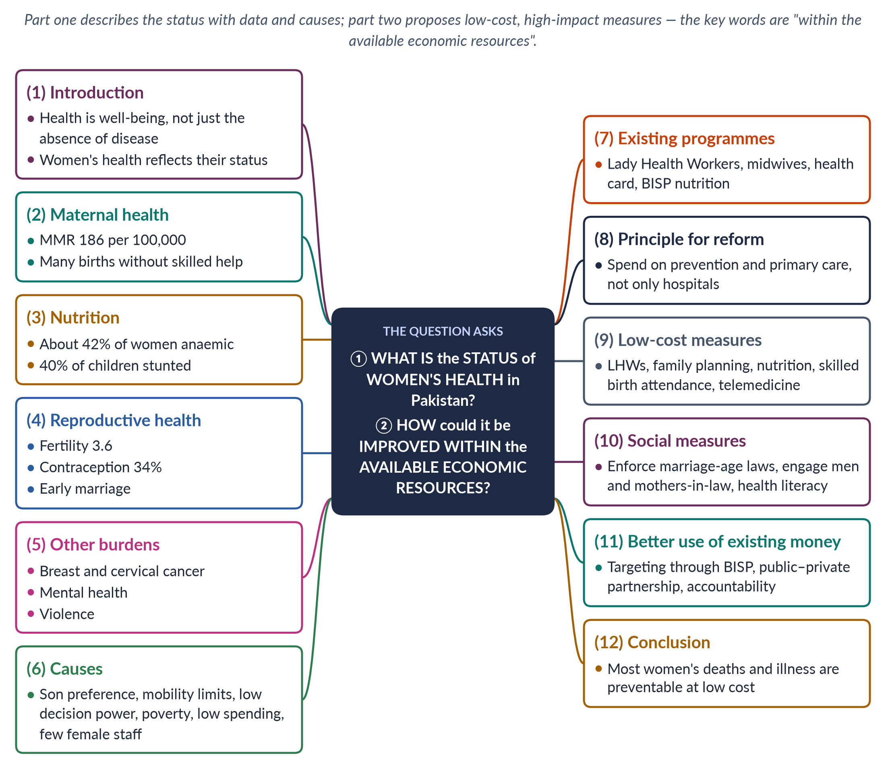
Figure 1 · The answer map: every branch is one numbered heading of the model answer below.

Decoding the question
Two parts. "What is the status" asks for a clear picture with indicators and dates, and ideally the causes. "How could it be improved within the available economic resources" is the key limb: the examiner wants cost-effective measures that do not depend on large new budgets — prevention, primary care, better targeting and social change. Say so explicitly.

The model answer

1. Introduction

i) Definition
The World Health Organization defines health as "a state of complete physical, mental and social well-being and not merely the absence of disease" (1946). Women's health covers the whole life cycle — childhood nutrition, adolescence, pregnancy and childbirth, and older age.

ii) The argument
Women's health in Pakistan is poor, especially in maternal health and nutrition, and it reflects women's low status: son preference, early marriage, restricted mobility and little say in decisions. Yet most of this ill-health is preventable at low cost. Pakistan can improve women's health substantially within existing resources by investing in prevention and primary care, using proven programmes better, and changing social practices.

2. Maternal health
The Pakistan Maternal Mortality Survey 2019 found a maternal mortality ratio of 186 deaths per 100,000 live births — far higher in rural areas and in Balochistan. Only about two-thirds of births were assisted by a skilled provider (PDHS 2017–18), and many rural women still give birth at home with untrained attendants. Most maternal deaths come from haemorrhage, hypertension, infection, obstructed labour and unsafe abortion — all preventable or treatable. The Egyptian obstetrician Mahmoud Fathalla called maternal death the end of a "road" that begins with neglect of girls long before pregnancy.

3. Nutrition
About 42% of women of reproductive age are anaemic, and about 40% of children under five are stunted (National Nutrition Survey 2018). In many households women eat last and least. An undernourished girl becomes an anaemic mother who has a low-birth-weight baby — an intergenerational cycle of malnutrition.

4. Reproductive health
The total fertility rate was about 3.6 and only about 34% of married women used contraception (PDHS 2017–18); many more want to delay or stop childbearing but lack access. Early marriage — the girls' age under the old federal law is still 16 in most provinces — means many adolescent pregnancies, which carry higher risks.

5. Other burdens

i) Cancers
Breast cancer is the most common cancer among Pakistani women and is often diagnosed late; a 2019 CSS paper cited about 13,000 deaths a year. Cervical cancer is also common.

ii) Mental health
Depression and anxiety are widespread among women, linked to violence, isolation, forced marriage and poverty, while services are scarce and stigma high.

iii) Violence and disasters
Domestic violence causes injury and trauma; the 2022 floods left about 650,000 pregnant women in affected areas (UNFPA).

6. Causes

i) Social and cultural
Son preference means girls may receive less food and care. Many women need permission or a male escort to visit a clinic, and decisions about care are often taken by husbands and mothers-in-law. Many women will see only a female doctor.

ii) Economic
Poverty and out-of-pocket costs for transport and medicines delay care.

iii) The health system
Public health spending has long been about 1% of GDP; rural facilities often lack staff and supplies; female health workers are scarce, and many women medical graduates do not practise.

iv) Education
Female literacy of about 53% (Census 2023) limits knowledge of nutrition, family planning and danger signs in pregnancy.
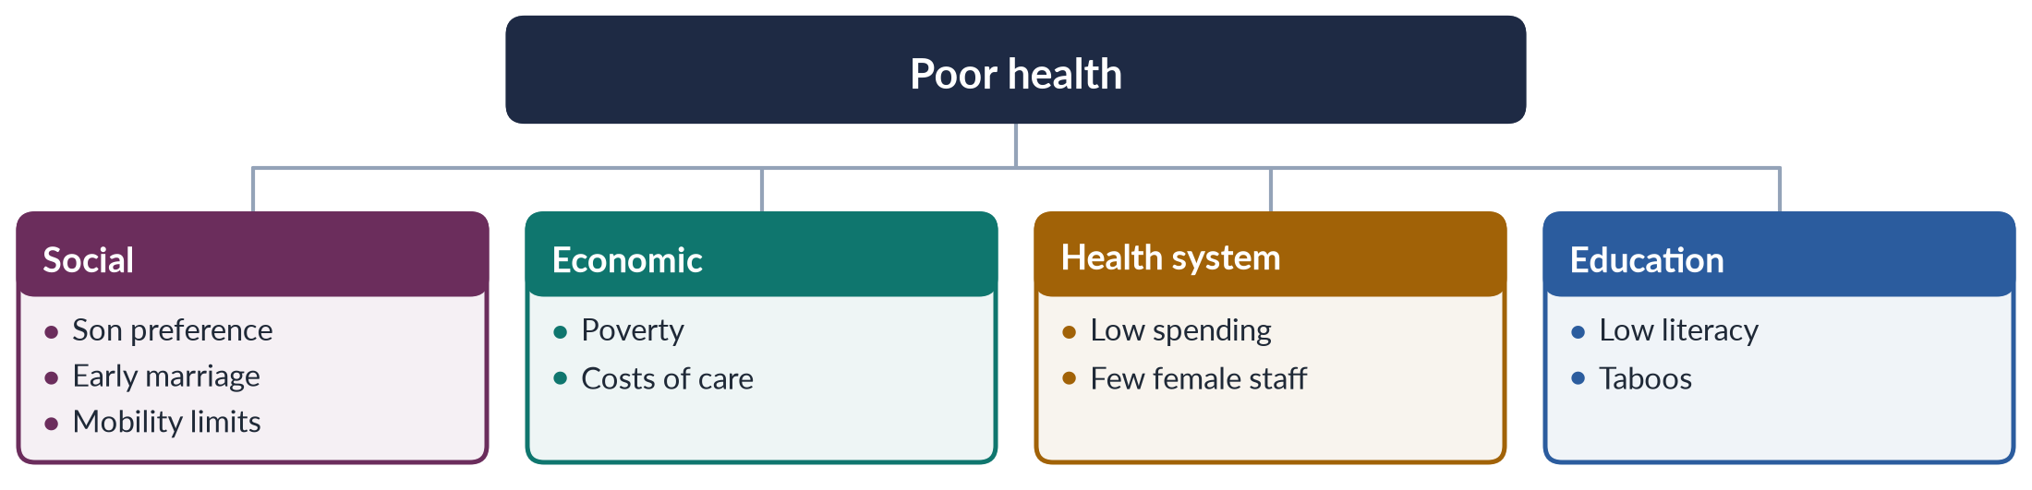
Figure 2 · The causes of women's poor health.

7. Existing programmes
Pakistan already has strong foundations. The Lady Health Worker Programme (1994) brings family planning, antenatal care and immunisation to homes; community midwives attend village births; the Sehat Sahulat health card covers hospital care; BISP and Benazir Nashonuma support poor women's nutrition. Articles 35 and 37(e) of the Constitution commit the state to protecting mothers and providing maternity benefits. The problem is less the absence of programmes than their coverage and quality: many rural areas have no LHW, midwives are too few, and the health card pays for hospital care but does little for the primary care where most deaths could be prevented.

An example of what works
The Lady Health Worker Programme, launched in 1994, shows what low-cost primary care can achieve: each worker serves about 1,000 people from her own home, providing family planning, antenatal advice, immunisation and referral. Independent evaluations linked the programme to higher contraceptive use and immunisation in the areas it covered — at a fraction of the cost of hospital care. Its weakness has been coverage and pay, not its model.

8. The principle: prevention and primary care
"Within available resources" means getting more health for the same money. The most cost-effective investments in women's health are in prevention and primary care — not expensive hospitals. Preventing an anaemic pregnancy or an unwanted birth costs far less than treating an emergency. International evidence consistently ranks family planning, skilled birth attendance, nutrition and community health workers among the best-value health investments in poor countries.

9. Low-cost measures

i) Expand and support LHWs and midwives
Fill vacant LHW posts, pay them on time and equip them — a cheap, proven way to reach rural women.

ii) Family planning
Make contraception available through LHWs, pharmacies and clinics; it is among the most cost-effective health investments.

iii) Nutrition
Iron and folic acid tablets, fortified flour and oil, and nutrition counselling cost little and cut anaemia.

iv) Skilled birth attendance and referral
Train and deploy community midwives; organise referral and transport (Rescue 1122) and blood banks for emergencies, so that complications are treated in time.

v) Telemedicine and female staff
Link women doctors working from home to rural clinics; offer incentives for women doctors to serve in rural posts.

10. Social measures
Enforce child-marriage laws and raise the age to 18 everywhere — later marriage means safer pregnancies. Engage men and mothers-in-law through LHWs, mosques and media so that women are allowed and encouraged to seek care. Spread health literacy — danger signs in pregnancy, breast self-examination, nutrition — through schools and mobile phones.

11. Better use of existing money
Target programmes to the poorest women using BISP data, so that scarce money reaches those at greatest risk; use public–private partnerships to run under-used facilities; and improve accountability so that drugs and staff reach rural facilities.
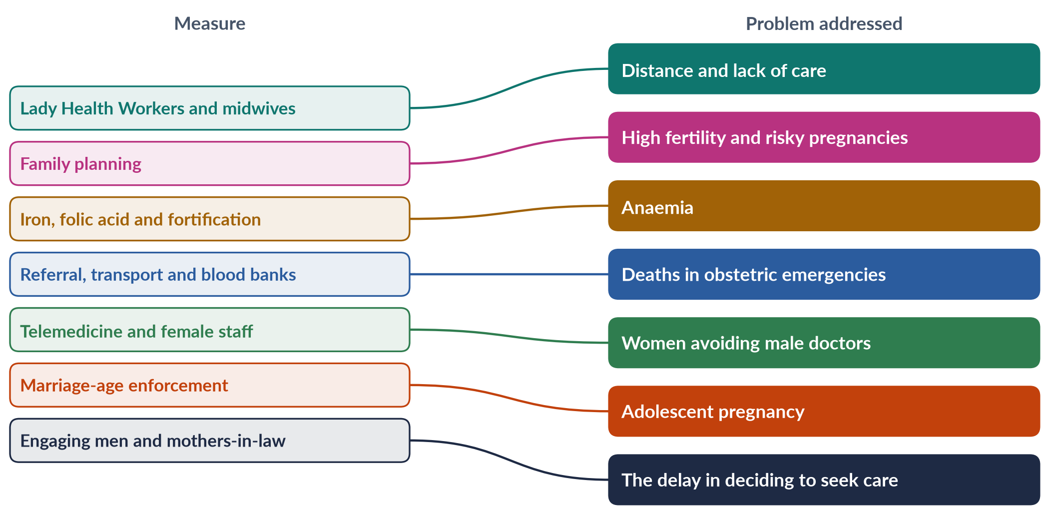
Figure 3 · Low-cost measures and the problems they address.

12. Conclusion
In sum, women's health in Pakistan is poor — an MMR of 186, anaemia in two-fifths of women, high fertility and late cancer diagnosis — because of low status, poverty and a weak health system. But most women's deaths and illness are preventable at low cost. By investing in LHWs, family planning, nutrition, skilled birth attendance and telemedicine, enforcing marriage-age laws and engaging families, Pakistan can make large gains within its available resources.

Why this answer scores
- The status is described with dated indicators and causes.
- The second limb is answered on its own terms — cost-effective measures, stated as a principle.
- A tree and a mapping figure link causes and remedies.
- Existing programmes are credited before new measures are proposed.

Answer 2 · Why Pakistan Ranks Second-Worst for Gender Inequality Despite Its Commitments (CSS 2018)
AT A GLANCE · CSS 2018 · Q5 · 20 MARKS
What reasons are responsible for ranking Pakistan as the second-worst country in the world for gender inequality despite Pakistan's commitment to many international conventions and the strong commitment to gender equality in the 1973 Constitution?

The answer map
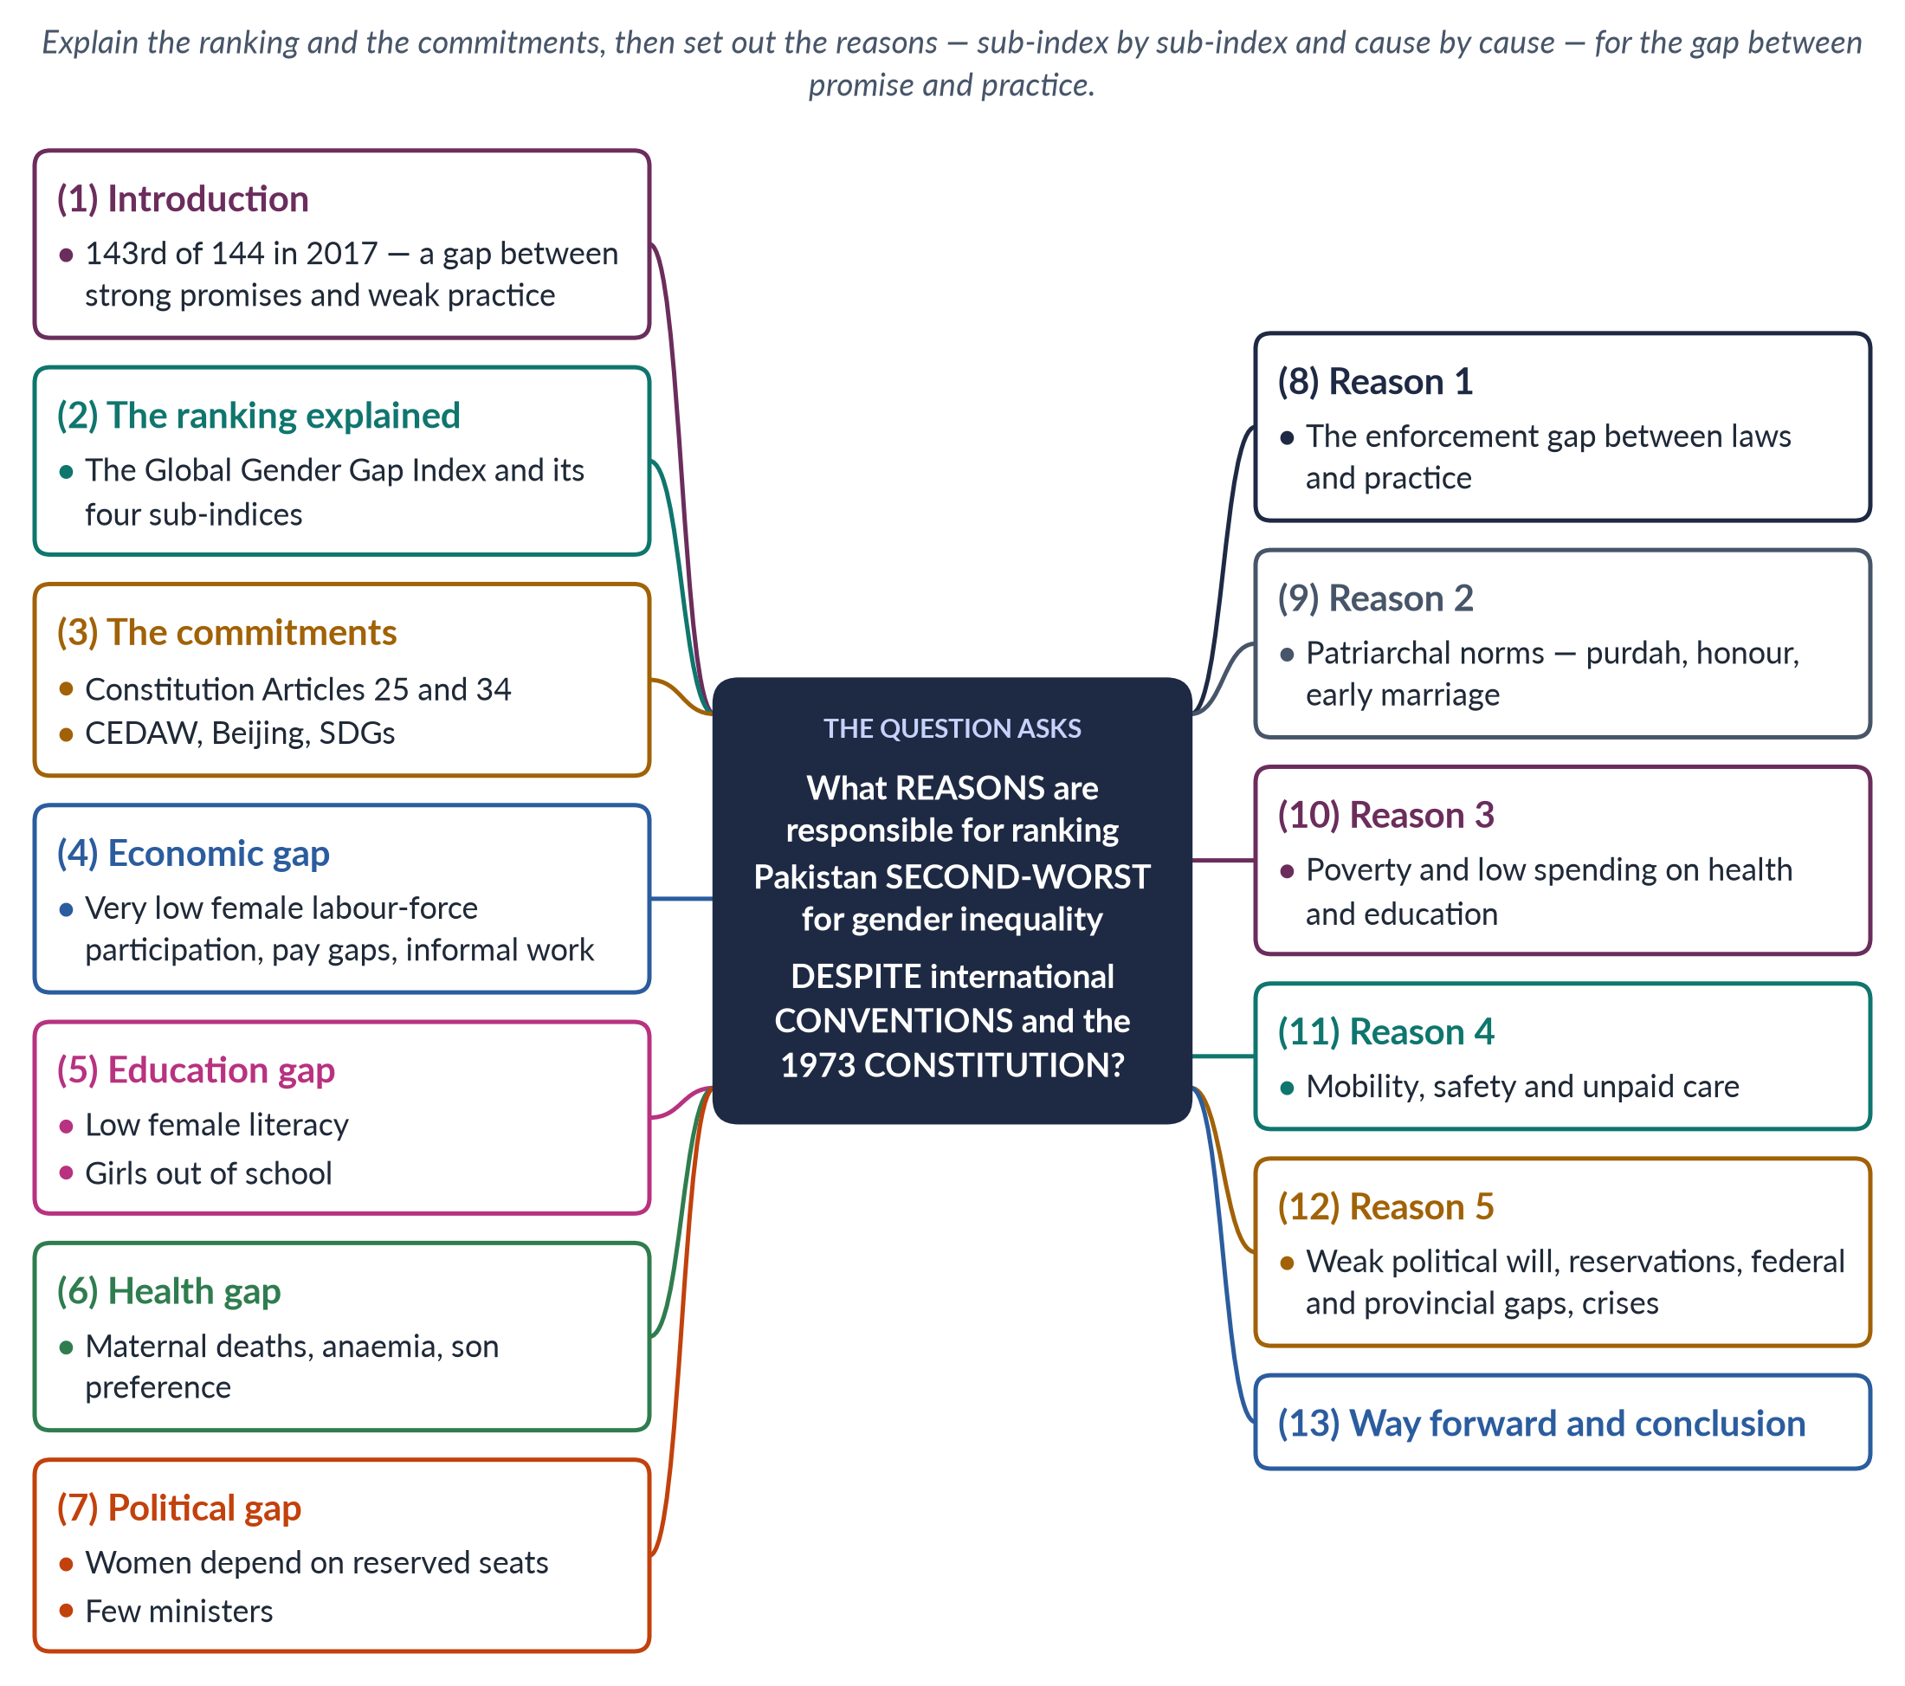
Figure 4 · The answer map: every branch is one numbered heading of the model answer below.

Decoding the question
"What reasons are responsible" asks for causes. The question contrasts two things — the ranking and the commitments — so you must explain both and then the gap between them. Use the index's four sub-indices to show where Pakistan falls short, then give the underlying reasons.

The model answer

1. Introduction

i) The ranking
In the World Economic Forum's Global Gender Gap Report 2017, Pakistan ranked 143rd of 144 countries — second-worst in the world, ahead only of Yemen. (By 2025 it had fallen to last, 148th of 148, before rising to 143rd of 145 in 2026.)

ii) The paradox
Pakistan's Constitution of 1973 promises equality, and Pakistan has joined major international conventions. Yet the gap between women and men remains among the widest in the world.

iii) The argument
The reasons lie in a persistent gap between promise and practice: laws are weakly enforced; patriarchal norms, poverty and low public spending limit women's health, education and work; unsafe mobility and unpaid care keep women at home; and political will and representation are weak.

2. The ranking explained
The Global Gender Gap Index (since 2006) measures how much of the gap between women and men a country has closed across four sub-indices: economic participation and opportunity, educational attainment, health and survival, and political empowerment. Pakistan scores lowest on the economic sub-index. Because the index measures gaps rather than absolute levels, a country can rank low even while making some progress, if other countries move faster — which has repeatedly happened to Pakistan.

3. The commitments

i) The Constitution
Article 25 guarantees equality before law and forbids discrimination on the basis of sex, while allowing special provisions for women; Article 34 requires steps to ensure women's full participation in national life; Article 35 protects mothers; Articles 51 and 106 reserve seats for women.

ii) International conventions
Pakistan acceded to CEDAW in 1996, adopted the Beijing Platform (1995), committed to the MDGs (2000) and later the SDGs (2015), and joined the core human-rights covenants.

4. The economic gap
Female labour-force participation has long been among the lowest in the world — 24.4% even in 2024–25, against roughly 80% for men. Most working women are in agriculture and informal work, often unpaid, and much of their labour is not counted as work at all. The ILO has reported one of the world's widest gender pay gaps in Pakistan, and very few women hold senior posts.

5. The education gap
Education is the foundation of the other dimensions, yet female literacy is far below male literacy — about 53% against 68% in the Census 2023 — and more than 25 million children are out of school, most of them girls, especially in rural areas and Balochistan.

6. The health gap
Health and survival also lag. Pakistan's maternal mortality ratio was 186 (2019); about 42% of women are anaemic; son preference affects girls' nutrition and care, and the sex ratio.

7. The political gap
Reserved seats have brought women into Parliament, but women's presence in the National Assembly still depends mainly on those 60 reserved seats; few women win general seats (only 11 in 2024), and women ministers are rare — in 2025 there were none.

In simple words
The Global Gender Gap Index is like a report card with four subjects. Pakistan signed many promises — the Constitution, CEDAW, Beijing, the SDGs — but promises do not appear on the report card; only results do. In 2017 the results in economic participation, education, health and politics were among the worst of the 144 countries ranked — hence "second-worst".

8. Reason 1: the enforcement gap
This is the most important reason. Pakistan has many pro-women laws — on harassment (2010), acid attacks and anti-women practices (2011), honour killings (2016) — but police, courts and local officials often fail to apply them. Women do not know their rights; cases take years; families and jirgas settle crimes privately. Laws on paper do not become rights in practice.

9. Reason 2: patriarchal norms
Purdah, family honour, son preference and early marriage limit girls' schooling, women's mobility and their work outside the home. Daughters are often seen as "belonging to another household", so parents invest less in their education. The male-breadwinner ideal makes women's paid work seem unnecessary or shameful in many families.

10. Reason 3: poverty and low spending
Pakistan has long spent only about 1% of GDP on health and around 2% on education. Weak public services hit women hardest, because families ration scarce resources in favour of sons. Rural health units often lack female staff, and many villages have no girls' secondary school.

11. Reason 4: mobility, safety and unpaid care

i) Mobility and safety
Unsafe public transport and harassment keep women from work and study; families often forbid daughters to travel far without an escort.

ii) Unpaid care
Without childcare, women carry the whole burden of housework and care, which limits their paid work. This unpaid work is not counted in national income, so its value is invisible to policy-makers.
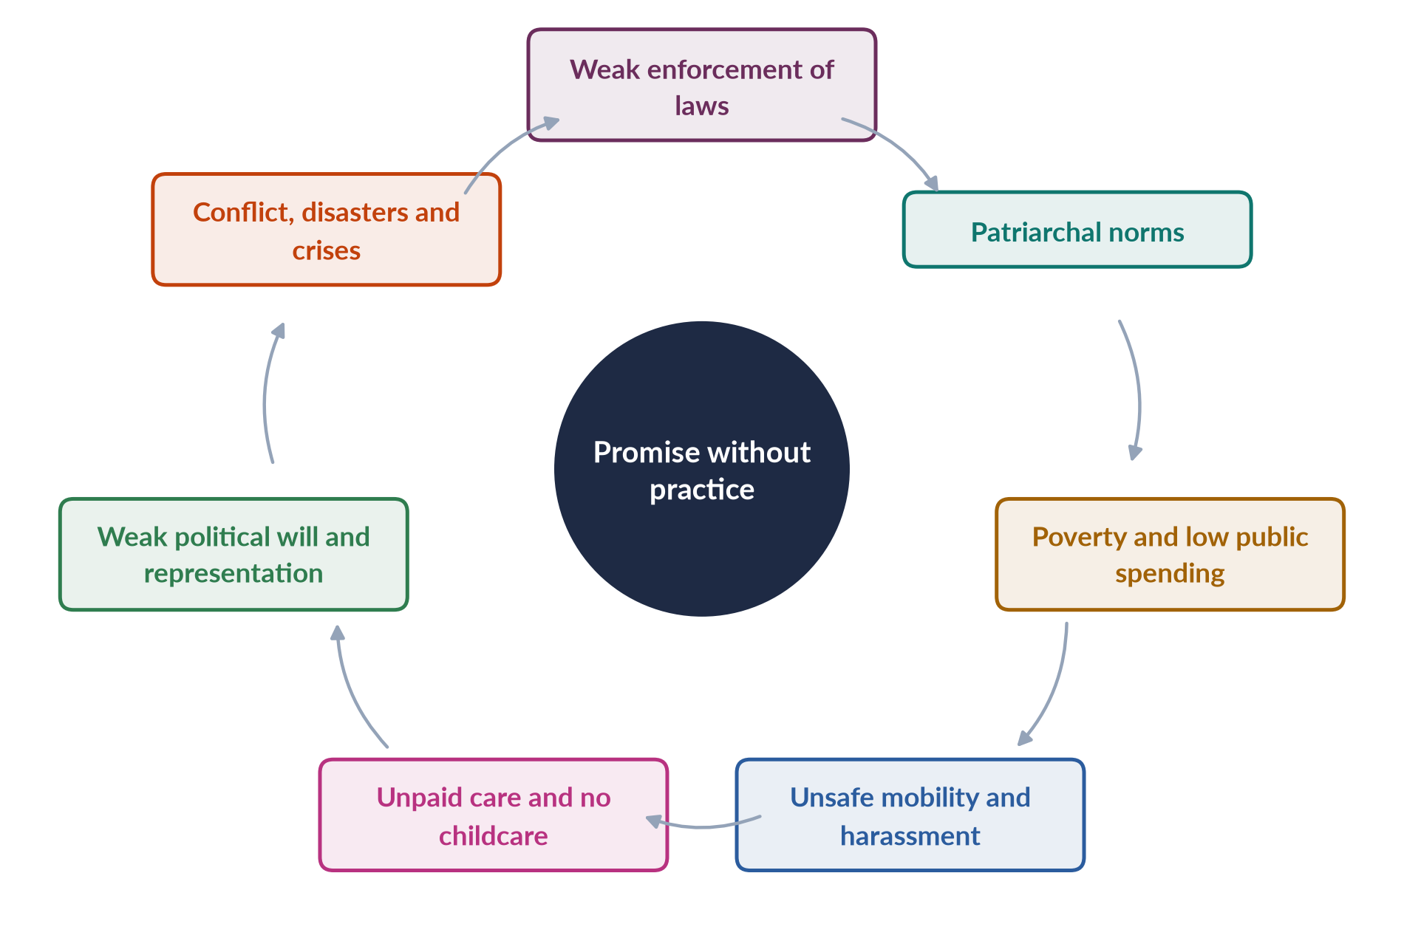
Figure 5 · Why Pakistan's gender gap persists despite its commitments.

12. Reason 5: politics, federalism and crises

i) Political will
Gender equality is seldom a political priority, and there are few women in decision-making positions to press for it. Budgets rarely assess their effects on women, and gender units in ministries have little authority.

ii) Reservations and resistance
Pakistan acceded to CEDAW with a declaration that it applies subject to the Constitution; religious bodies such as the Council of Islamic Ideology have opposed several reforms.

iii) Federalism
After the 18th Amendment (2010), women's development moved to the provinces, whose laws and capacity differ.

iv) Crises
Militancy (attacks on girls' schools in Swat and the former tribal areas), natural disasters such as the 2022 floods, and economic crises with IMF-linked austerity have repeatedly set back women's gains.

13. Way forward and conclusion

i) Way forward
Enforce existing laws; invest in girls' secondary schools and primary health care; create safe transport and childcare so women can work; raise the marriage age to 18 in every province; appoint women ministers and strengthen women's representation; and track progress with sex-disaggregated data. The rise to 143rd in 2026 — driven by education and political empowerment — shows that policy can move the ranking.

ii) Conclusion
Pakistan's low ranking is not due to a lack of promises — its Constitution and treaties are strong. It is due to a gap between promise and practice, rooted in norms, poverty, weak enforcement and weak political will. Closing that gap — especially in women's economic participation — is the key to moving up the index.

Why this answer scores
- Explains both the ranking (four sub-indices) and the commitments, then the gap between them.
- Gives five clear reasons, each with evidence.
- A cycle figure shows how the reasons reinforce each other.
- Up-to-date data (2024–25, 2025, 2026) show awareness of the current position.

Answer 3 · Paid Employment and Women's Reproductive Roles: Challenges Worldwide and in Pakistan (CSS 2019)
AT A GLANCE · CSS 2019 · Q6 · 20 MARKS
Women's participation in the labour force has increased recently, yet women continue to perform their reproductive roles. Discuss the challenges encountered by women as a result of paid employment worldwide, with special reference to Pakistan.

The answer map
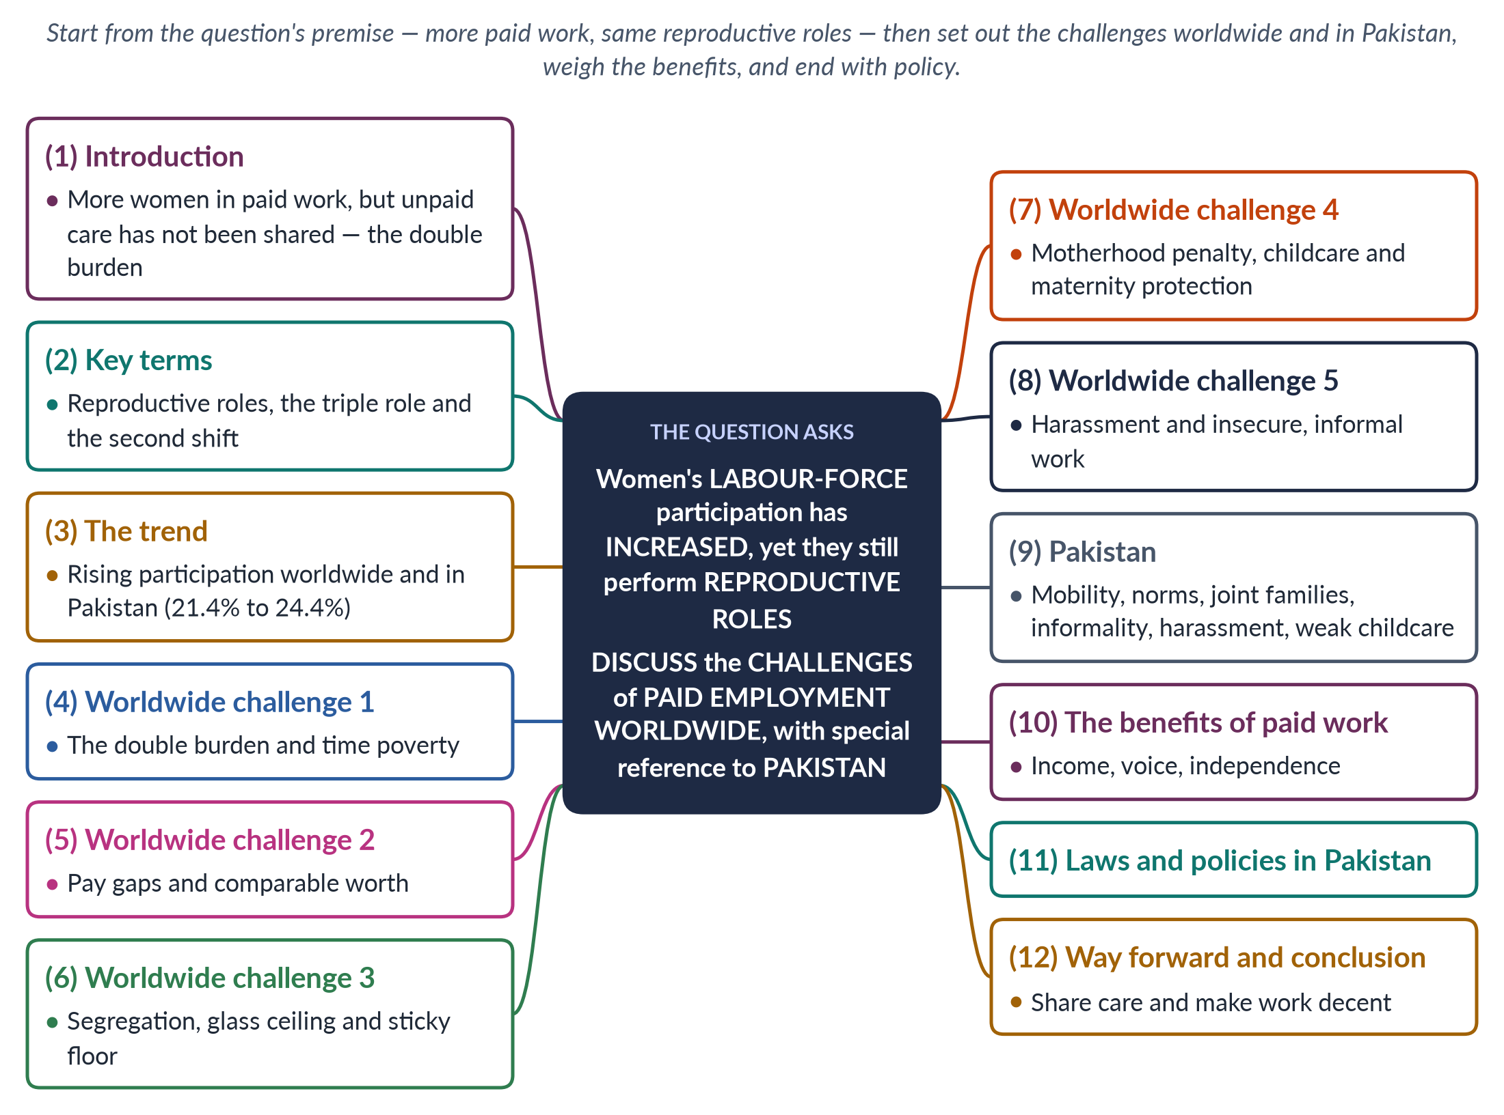
Figure 6 · The answer map: every branch is one numbered heading of the model answer below.

Decoding the question
The question states a premise: participation has risen, but women still carry reproductive roles. "Discuss the challenges … worldwide, with special reference to Pakistan" asks for the problems that arise when paid work is added to unpaid care — first globally, then in more detail for Pakistan. Use the MCQ terms (glass ceiling, sticky floor, comparable worth) and end with policy.

The model answer

1. Introduction

i) The premise
Across the world, more women have entered paid work in recent decades. But men have not taken on an equal share of unpaid work at home. As a result, most working women carry a double burden: a paid job plus the housework and care that society still expects of them.

ii) The argument
Paid work brings women income and independence, but it also brings serious challenges — time poverty, unequal pay, blocked careers, lack of childcare, harassment and insecure jobs. In Pakistan, these are sharpened by restricted mobility, social norms and the dominance of informal work. The solution is not to keep women at home but to share care and make work decent.

2. Key terms

i) Reproductive roles
Reproductive roles are the unpaid work of bearing and raising children and maintaining the household — cooking, cleaning, fetching water and caring for the sick and elderly.

ii) The triple role
Caroline Moser (1993) described women's triple role: productive (paid or income-earning) work, reproductive work and community-managing work.

iii) The second shift
The sociologist Arlie Hochschild (The Second Shift, 1989) showed that working women come home to a "second shift" of housework and childcare.

3. The trend
Globally, women do about three times as much unpaid care work as men (ILO, 2018). In Pakistan, female labour-force participation rose from about 21.4% (2020–21) to 24.4% (LFS 2024–25) — still among the lowest in the world, with large provincial differences: Punjab 33.8%, Balochistan 14.5%.

4. Worldwide challenge 1: the double burden and time poverty
When paid hours are added to unpaid hours, women work longer total days than men and have little time for rest, study or leisure — a condition called time poverty. Fatigue and stress affect health; some women drop out of paid work when care demands rise, for example after the birth of a child.

5. Worldwide challenge 2: unequal pay and comparable worth

i) The pay gap
Women earn less than men almost everywhere, partly because they work in lower-paid sectors and fewer hours, and partly because of discrimination.

ii) Comparable worth
Comparable worth means equal pay for work of equal value. Where it is denied, "women's jobs" such as nursing, teaching and garment work are paid less than men's jobs of similar skill — "sex segregation and less pay for women's work" (MCQ 2023).

6. Worldwide challenge 3: blocked careers

i) Occupational segregation
Women are crowded into a narrow range of jobs — care, teaching, clerical and garment work.

ii) The glass ceiling
The glass ceiling is the set of invisible barriers that stop women rising to the top (MCQ 2024); women hold a small share of senior management and board posts.

iii) The sticky floor
The sticky floor describes women stuck in low-wage, low-mobility jobs with little chance of promotion (MCQ 2026).

7. Worldwide challenge 4: motherhood and care

i) The motherhood penalty
Mothers often lose pay and promotion after having children, while fathers do not.

ii) Childcare
Affordable, good-quality childcare is scarce in many countries.

iii) Maternity protection
Many women, especially in informal work, have no paid maternity leave or job protection.

8. Worldwide challenge 5: harassment and insecurity

i) Harassment
Sexual harassment at work and on the way to work is widespread; the #MeToo movement (2017) exposed its scale.

ii) Insecure work
Many new jobs for women — in export factories, home-based subcontracting and platform work — are informal, without contracts, pensions or social security (Guy Standing's "feminisation of labour", 1989).
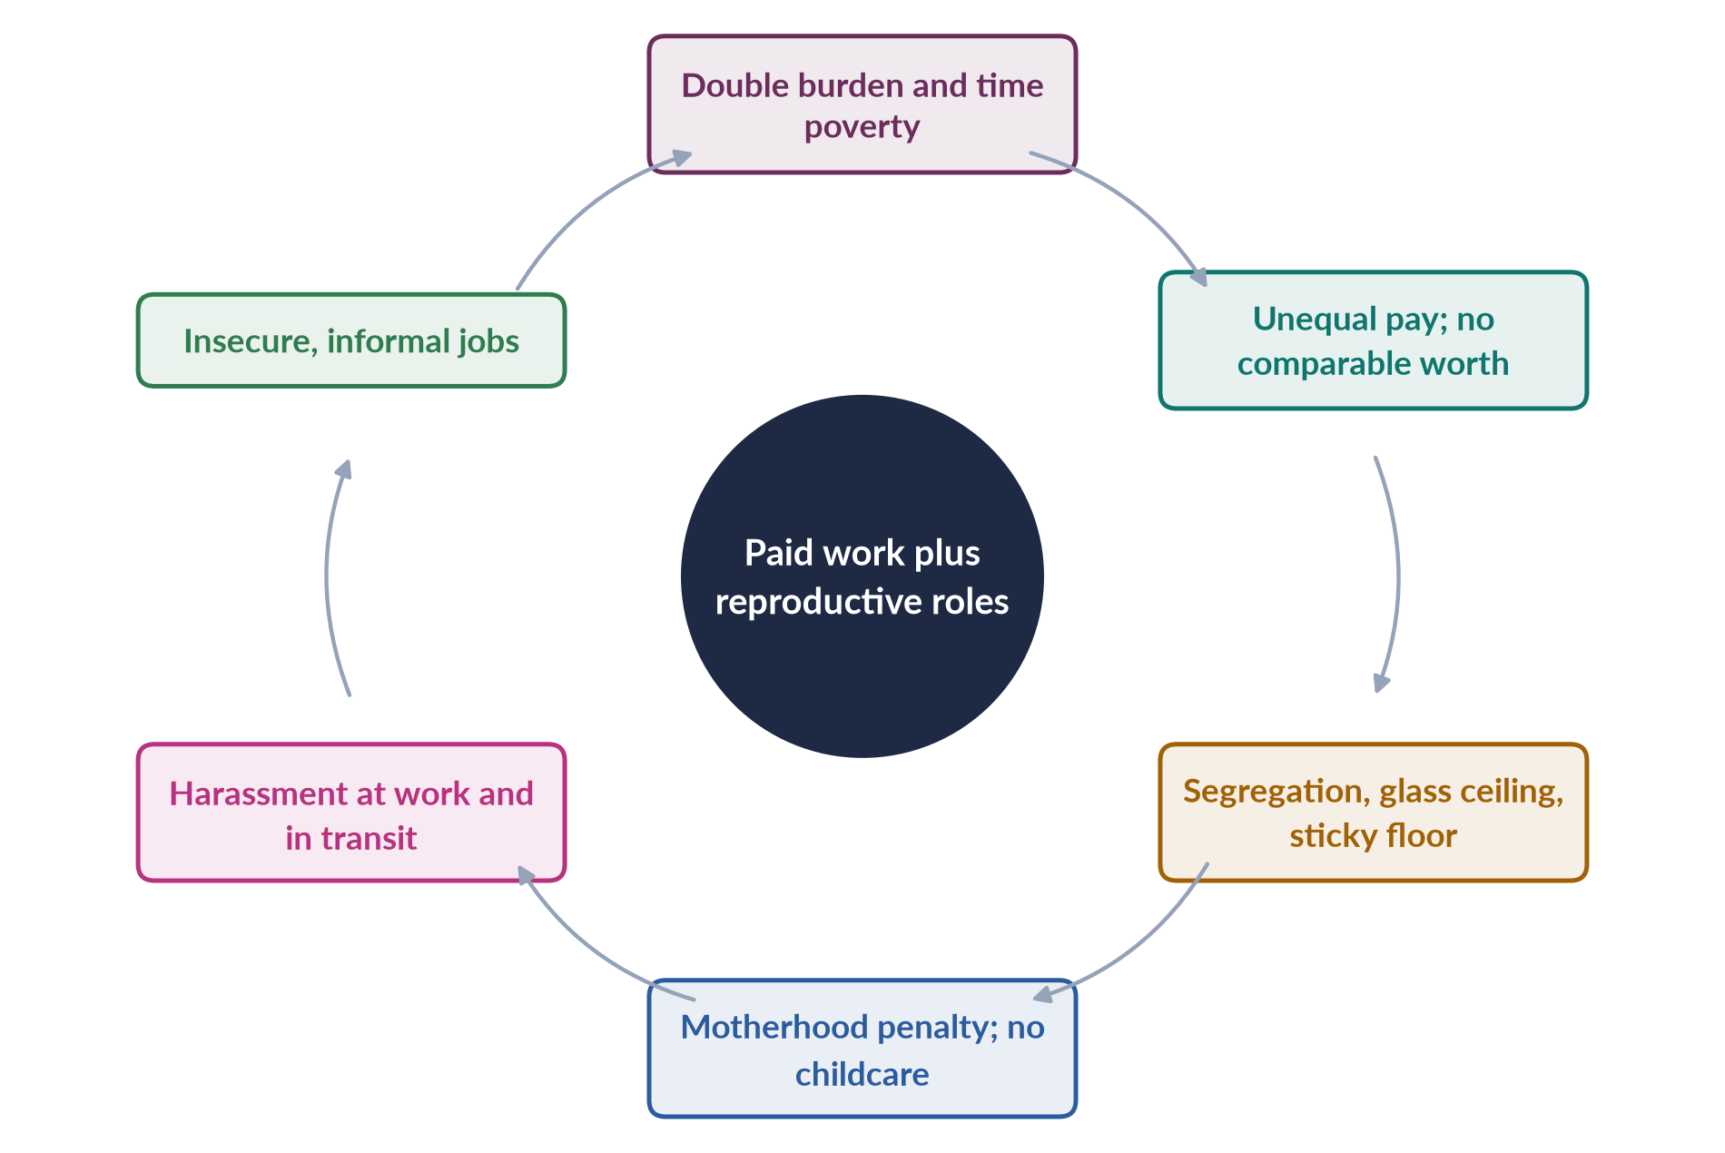
Figure 7 · The challenges of paid work on top of reproductive roles.

9. The challenges in Pakistan

i) Mobility and safety
Unsafe, crowded public transport and street harassment make getting to work difficult; many families forbid daughters to travel alone.

ii) Social norms
The ideal of the male breadwinner and family honour discourage women's work outside the home; many families accept only teaching or medicine.

iii) The joint family
In joint families, working women are often still expected to cook and care for in-laws, so the double burden is heavier.

iv) Informality and low pay
Most working women are in agriculture or home-based piece work, paid little or nothing, with no protection. The ILO has reported one of the widest gender pay gaps in the world in Pakistan.

v) Harassment at work
The Protection against Harassment of Women at the Workplace Act 2010 (amended 2022) requires inquiry committees and created an ombudsperson, but enforcement is weak in the private and informal sectors.

vi) Childcare and maternity
Few employers provide day care; maternity benefits reach mainly public-sector and formal workers.

vii) Educated women leaving work
Many educated women — including large numbers of doctors — leave work after marriage because they cannot combine it with family expectations.

An example
A woman teacher in a Punjab village who earns her own salary may still cook, clean and care for children and in-laws before and after school — the double burden in its sharpest form. Without childcare, transport or help at home, many such women give up work after marriage or the birth of a first child, which helps explain why female participation is only 24.4%.

10. The benefits of paid work
Despite these challenges, paid work brings women income, independence, confidence and a stronger voice at home. Naila Kabeer's research on Bangladeshi garment workers (The Power to Choose, 2000) found that paid work delayed marriage and increased women's bargaining power. The goal is therefore to remove the challenges, not to keep women out of work.

11. Laws and policies in Pakistan
Pakistan has taken some steps: the Harassment Act 2010; a 10% quota for women in federal services; the Sindh Home-Based Workers Act 2018 and Sindh Maternity Benefits Act 2018; the Punjab Domestic Workers Act 2019; and the federal Maternity and Paternity Leave Act 2020, which extended maternity leave and introduced paternity leave. Coverage of informal workers remains the main gap.

12. Way forward and conclusion

i) Way forward
Provide safe transport and enforce harassment laws; build workplace day care and public crèches; introduce paternity leave and campaigns for men to share housework; enforce equal pay for work of equal value; extend protection to home-based and domestic workers; count unpaid care through time-use surveys (SDG target 5.4).

ii) Conclusion
Women's entry into paid work is progress, but it has come without a matching change in reproductive roles. Worldwide and in Pakistan, the result is a double burden, unequal pay, blocked careers and insecurity — made worse in Pakistan by restricted mobility, social norms and informality. The answer is to recognise, reduce and redistribute care and to make work decent, so that paid employment empowers women rather than exhausting them.

Why this answer scores
- Builds from the question's premise (more paid work, same reproductive roles).
- Covers worldwide challenges and then Pakistan in more depth, as instructed.
- Uses the examiner's own MCQ concepts — glass ceiling, sticky floor, comparable worth.
- A cycle figure, Pakistani laws and a policy section complete a balanced answer.

Answer 4 · A System That Guarantees Human Rights: Evaluating Pakistan (CSS 2020)
AT A GLANCE · CSS 2020 · Q6 · 20 MARKS
'For realizing, in letter and spirit, the ideals of a democratic welfare state, it is necessary to institute a system which fully guarantees human rights, generates a conducive environment for the pragmatic use and beneficial enjoyment of human rights, and provides operative safeguards and expeditious remedy against any violation of human rights.' Critically evaluate the statement with special reference to Pakistan.

The answer map
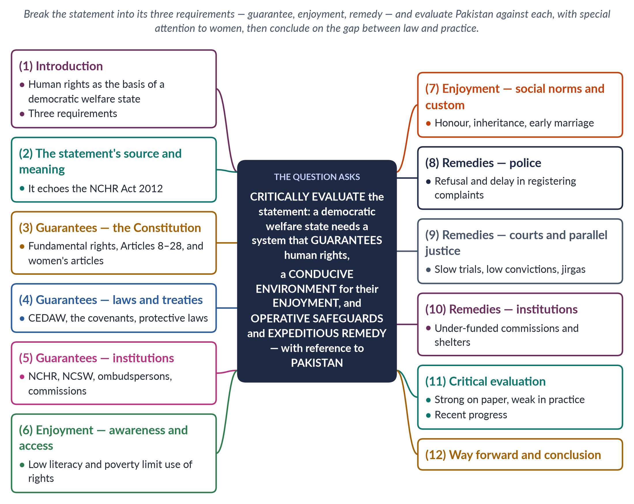
Figure 8 · The answer map: every branch is one numbered heading of the model answer below.

Decoding the question
The statement sets out three requirements for a democratic welfare state: (1) a system that fully guarantees human rights; (2) an environment that allows their practical use and enjoyment; and (3) operative safeguards and expeditious remedy against violations. "Critically evaluate … with special reference to Pakistan" asks you to test Pakistan against each requirement, with evidence, and to judge how far it meets them. Women's rights are the natural focus in a Gender Studies paper.

The model answer

1. Introduction

i) Definition
Human rights are the rights every person has because they are human — to life, dignity, equality, liberty and a decent standard of living. A democratic welfare state is one whose government is elected and which takes responsibility for its citizens' welfare and rights.

ii) The argument
The statement is right that rights on paper are not enough: people must be able to enjoy them and obtain speedy remedies when they are violated. Pakistan meets the first requirement fairly well — its Constitution, laws and institutions provide broad guarantees. It meets the second and third far less well, especially for women, because of poverty, social norms, weak policing and slow justice.

2. The statement's source and meaning
The wording closely follows the preamble of Pakistan's National Commission for Human Rights Act 2012, which created an independent national human-rights institution. It describes a system in three layers: legal guarantees, a supportive environment and effective remedies. The logic is simple: a right that people do not know about, cannot afford to use, or cannot enforce when it is violated is a right only on paper.
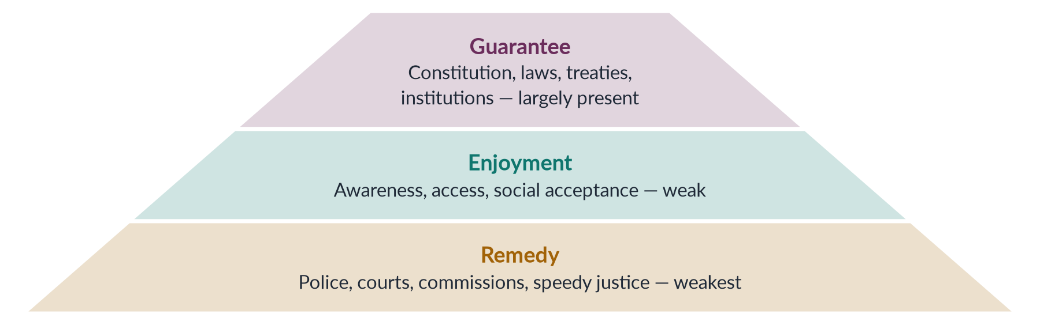
Figure 9 · The three requirements of the statement, tested for Pakistan.

3. Guarantees — the Constitution
The Constitution of 1973 lists fundamental rights in Articles 8–28, including security of person (Art. 9), dignity (Art. 14), freedom of speech and assembly, and equality (Art. 25). Article 8 declares laws inconsistent with these rights void, and the superior courts can enforce them (Articles 184(3) and 199). For women, Article 25 forbids discrimination on the basis of sex while allowing special measures; Article 34 requires women's full participation; Article 35 protects mothers and children; and Article 25A (2010) guarantees free education for ages 5–16.

4. Guarantees — laws and treaties

i) International treaties
Pakistan has joined CEDAW (1996), the Convention on the Rights of the Child (1990), the ICESCR (2008), the ICCPR (2010) and the Convention against Torture (2010).

ii) Protective laws
Since 2006 Parliament and the provinces have passed many laws for women: the Women's Protection Act 2006; the Harassment Act 2010; the Acid and Anti-Women Practices Acts 2011; provincial domestic violence laws (Sindh 2013 to Islamabad 2025); the anti-honour-killing law 2016; the Anti-Rape (Investigation and Trial) Act 2021; and the Islamabad Child Marriage Restraint Act 2025.

5. Guarantees — institutions
The National Commission on the Status of Women (2000, strengthened in 2012), the National Commission for Human Rights (2012), a Ministry of Human Rights, federal and provincial harassment ombudspersons, provincial women's commissions and violence-against-women centres form a broad institutional framework. On paper, Pakistan largely meets the first requirement. Its periodic reports to UN treaty bodies and its Universal Periodic Review at the UN Human Rights Council show a formal commitment to international standards, and the EU's GSP+ trade preferences (from 2014) depend on implementing 27 conventions.

6. Enjoyment — awareness and access

i) Awareness
Many women do not know their rights. Female literacy is only about 53% (Census 2023), and legal information rarely reaches rural areas.

ii) Access
Poverty, distance, the cost of lawyers and the lack of identity documents (CNICs) stop many women from using their rights — for example, to claim inheritance or register a marriage.

7. Enjoyment — social norms and custom
Custom often overrides law. Women are pressured to give up inheritance to brothers; early and forced marriages continue; family honour restricts women's movement, work and choice of spouse. A conducive environment for the "beneficial enjoyment" of rights does not yet exist for many women. Religious minority women face additional barriers, including reported forced conversions; poor women, disabled women and khawaja siras face exclusion from services and justice.

8. Remedies — the police
Women who report violence often find the police unwilling to register complaints, pressing them to reconcile, or treating them with suspicion. There are few women police officers, though women's police stations and gender desks have been set up since 1994.

9. Remedies — courts and parallel justice

i) Slow justice
Courts are slow and expensive; cases can take years, and conviction rates for rape and domestic violence are low, partly because of weak investigation and forensic evidence.

ii) Compromise and jirgas
Families and jirgas often settle crimes privately. Under the Qisas and Diyat laws, families could "forgive" killers in honour cases until the 2016 law made life imprisonment mandatory.

10. Remedies — institutions
Commissions and shelters are often under-funded, understaffed or leaderless for long periods. Shelters (Dar-ul-Aman) are few and overcrowded. The "operative safeguards and expeditious remedy" the statement demands are the weakest part of the system. After the 18th Amendment (2010), provinces legislate separately, so the protection a woman receives can depend on where she lives.
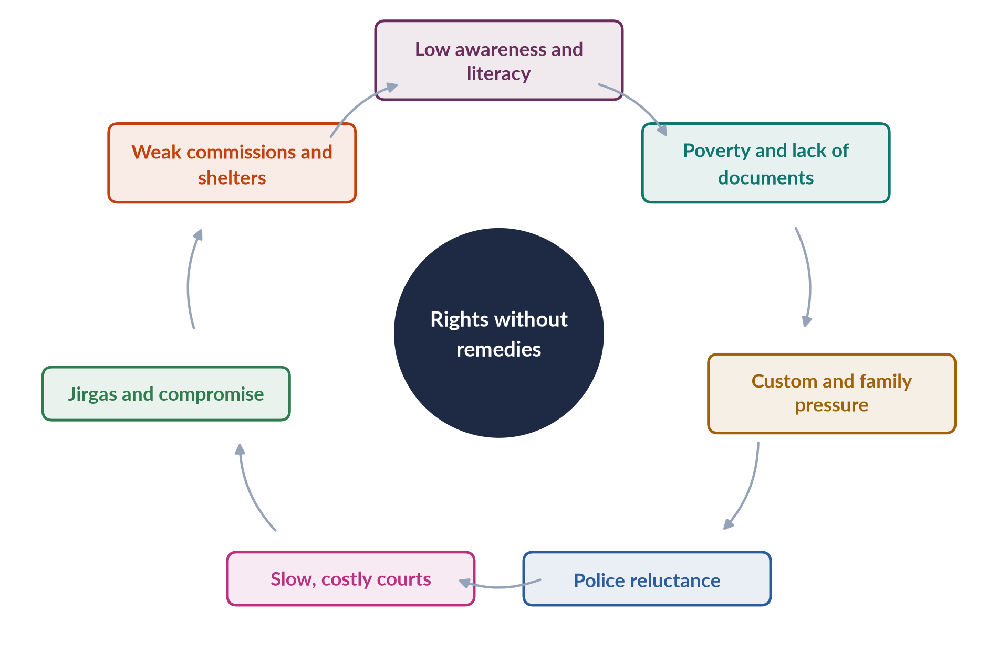
Figure 10 · Why rights fail to become remedies for Pakistani women.

An example: the honour-killing loophole
For years, the law guaranteed the right to life on paper while the Qisas and Diyat provisions let an honour killer be forgiven by his own family. The guarantee existed; the remedy did not. Only after the murder of Qandeel Baloch in 2016 did Parliament require life imprisonment even after forgiveness — and even then her brother was acquitted in 2022 after a parental pardon.

11. Critical evaluation

i) Strengths
Pakistan has built a strong legal framework over two decades, often after women's campaigns; courts have extended rights (for example, the Saima Waheed case, 2004, on a woman's right to marry by choice); new institutions such as special rape courts (2021) respond to past failures.

ii) Weaknesses
The gap between law and practice remains wide. Pakistan's rank of 143rd of 145 in the Global Gender Gap Report 2026 reflects this gap.

iii) Verdict
The statement is correct in its analysis and Pakistan meets it only partly: strong on guarantees, weak on enjoyment and remedy.

12. Way forward and conclusion

i) Way forward
Legal literacy for women through schools, media and Lady Health Workers; gender-sensitive policing with more women officers; special courts, legal aid and forensic labs for speedy justice; one-stop centres in every district; funded, independent commissions; and harmonised laws across provinces.

ii) Conclusion
A democratic welfare state is measured not by the rights written in its Constitution but by whether its citizens — including its poorest women — can enjoy those rights and obtain speedy remedies. Pakistan has built the first floor of this system; it must now build the second and third — so that the promise of the Constitution reaches every woman in practice.

Why this answer scores
- The statement is broken into its three requirements, and Pakistan is tested against each.
- Evidence covers the Constitution, treaties, laws and institutions, and the practical barriers.
- A pyramid and a cycle figure show the gap between guarantees and remedies.
- The evaluation is balanced and ends with concrete reforms.

Answer 5 · Women's Health Status and Measures to Improve Women's Status as a Whole (CSS 2023)
AT A GLANCE · CSS 2023 · Q7 · 20 MARKS
Elucidate the current health status of women in Pakistan. What measures could be taken to improve women's status as a whole? Support your arguments with suitable examples.

The answer map
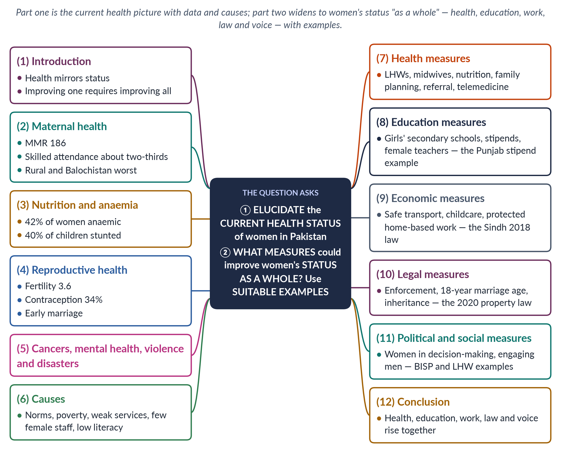
Figure 11 · The answer map: every branch is one numbered heading of the model answer below.

Decoding the question
Two parts. "Elucidate the current health status" asks for a clear, up-to-date picture with data. "What measures could be taken to improve women's status as a whole" widens the frame beyond health to all dimensions — education, employment, law, politics. "Support your arguments with suitable examples" means each measure needs a named programme, law or case.

The model answer

1. Introduction

i) Definition
Women's health is complete physical, mental and social well-being across the life cycle. Women's status is their overall position — rights, resources, respect and power — relative to men.

ii) The argument
Women's health in Pakistan is poor, especially in maternal health and nutrition, because women's status is low: health reflects education, income, legal protection and voice. Measures to improve women's status "as a whole" must therefore work across dimensions, and Pakistan already has examples of what works.

2. Maternal health
Pakistan's maternal mortality ratio was 186 per 100,000 live births (Pakistan Maternal Mortality Survey 2019). Only about two-thirds of births were assisted by a skilled provider (PDHS 2017–18). Deaths are highest in rural areas and Balochistan, where distances are long and female staff scarce. Most deaths — from haemorrhage, hypertension, infection and obstructed labour — are preventable. The Egyptian doctor Mahmoud Fathalla described such deaths as the end of a "road" of neglect that begins in girlhood.

3. Nutrition and anaemia
About 42% of women of reproductive age are anaemic, and about 40% of children under five are stunted (National Nutrition Survey 2018). Women often eat last and least, and anaemic mothers have weaker babies — an intergenerational cycle. Anaemia also raises the risk of death from bleeding in childbirth and reduces women's energy for work and study.

4. Reproductive health
The total fertility rate was about 3.6, and only about 34% of married women used contraception (PDHS 2017–18). Early marriage — the old federal age for girls is 16 — leads to adolescent pregnancies with higher risks. Pakistan's population, about 241 million in the Census 2023, is growing at about 2.55% a year.

5. Other burdens

i) Cancers
Breast cancer is the leading cancer among women and is often detected late; cervical cancer is also common. Pakistan began introducing the HPV vaccine for girls in 2025.

ii) Mental health
Depression and anxiety are common, linked to violence, isolation after marriage, forced marriage and pressure to bear sons; services are scarce and stigma keeps women from seeking help.

iii) Violence and disasters
Domestic violence harms women's physical and mental health; the 2022 floods left about 650,000 pregnant women in affected areas (UNFPA).

6. Causes

i) Social norms
Son preference, early marriage, restricted mobility and women's low decision-making power over their own care.

ii) Economic barriers
Poverty and out-of-pocket costs for transport, medicines and private care, which families spend on sons before daughters.

iii) Health-system weakness
Public health spending of about 1% of GDP, rural facilities without staff or drugs, and a shortage of female doctors. Many women medical graduates never practise, while rural women will often see only a woman.

iv) Low literacy
Female literacy of about 53% (Census 2023) limits knowledge of nutrition, family planning and danger signs.

7. Health measures

i) Community health workers
Strengthen the Lady Health Worker Programme (1994), which brings family planning, antenatal care and immunisation to homes and has been linked to better maternal and child health. Filling vacant posts and paying LHWs on time are cheap, high-impact steps.

ii) Skilled birth attendance and referral
Deploy community midwives; ensure ambulances (Rescue 1122) and blood banks for emergencies, so that complications are treated before it is too late.

iii) Nutrition and family planning
Iron and folic acid, food fortification, and contraception through LHWs and pharmacies.

iv) Telemedicine
Connect women doctors working from home to rural clinics — addressing both the shortage of female doctors and women's reluctance to see male doctors.

8. Education measures
Education is the foundation of women's status. Build girls' middle and secondary schools within reach, recruit female teachers, and pay stipends for girls' attendance. Example: Punjab's female school stipend programme (from 2004) raised girls' secondary enrolment. Girls who stay in school marry later and have healthier children, so education is also a health measure. Enforce Article 25A (free, compulsory education to age 16).

9. Economic measures
Paid work gives women income and voice. Provide safe transport and enforce the Harassment Act 2010; build day-care facilities; protect home-based and domestic workers. Examples: the Sindh Home-Based Workers Act 2018 recognised home-based workers' rights; the federal Maternity and Paternity Leave Act 2020 extended maternity leave and introduced paternity leave. Female labour-force participation of 24.4% (2024–25) shows how much remains; women with their own income are better able to pay for and decide on their own health care.

10. Legal measures

i) Enforce existing laws
Train police, set up one-stop centres, and speed up justice — as the Anti-Rape (Investigation and Trial) Act 2021 attempts with special courts.

ii) Marriage age
Raise the minimum age to 18 everywhere. Example: Sindh (2013) and Islamabad (2025) have already done so.

iii) Inheritance
Help women claim property. Example: the Enforcement of Women's Property Rights Act 2020 lets women complain to an ombudsperson.

11. Political and social measures

i) Women in decision-making
Appoint women ministers — there were none in 2025 — and strengthen women's roles in legislatures, local government and the bureaucracy. Women legislators of the Women's Parliamentary Caucus (2008) drove many of the laws of 2010–2016.

ii) Social protection
Example: the Benazir Income Support Programme (2008) pays cash directly to women, giving them money of their own and some bargaining power.

iii) Engaging men and communities
Involve husbands, mothers-in-law and religious leaders in supporting women's health, schooling and work. Campaigns that explain Islam's support for birth spacing, girls' education and women's inheritance have helped change attitudes in some districts.
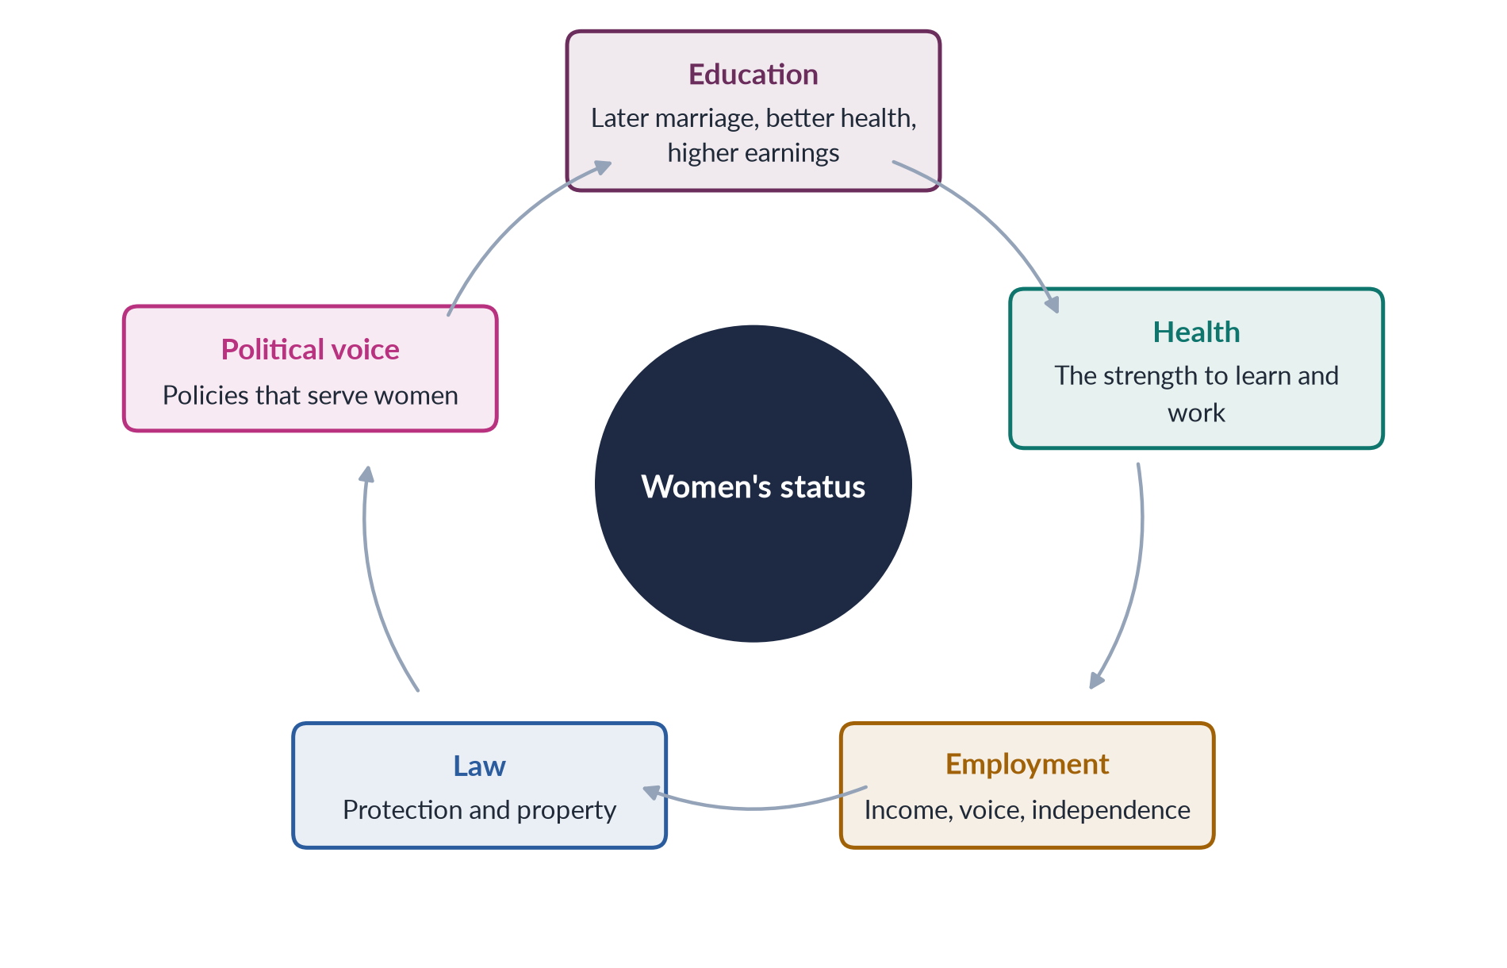
Figure 12 · How improvements in one dimension lift women's status as a whole.

iv) In simple words
Improving women's health without improving their status is like treating a fever without treating the infection. A woman who can read, earn, own property and speak in decisions will seek care earlier, space her pregnancies and feed her children better — so measures for women's status as a whole are also the best health measures.

12. Conclusion
Women's health in Pakistan — an MMR of 186, anaemia in two-fifths of women, high fertility — mirrors their low overall status. Improving it requires more than clinics: it needs girls' education, decent work, enforced laws and women's voice in decisions. Pakistan already has working examples — the LHW Programme, Punjab's girls' stipends, BISP, Sindh's home-based workers law and new marriage-age laws. Scaling them up would raise women's status as a whole.

Why this answer scores
- An up-to-date health picture with dated data and causes.
- The second part is answered across dimensions, as "status as a whole" requires.
- Every measure has a suitable example — a named programme, law or case.
- A cycle figure shows how the dimensions reinforce each other.

Answer 6 · The "Maternity Death Road" and Women's Health in Pakistan's Social, Cultural and Demographic Context (CSS 2024)
AT A GLANCE · CSS 2024 · Q2 · 20 MARKS
An Egyptian doctor, Mahmoud Fathalla, uses the term 'maternity death road' while discussing issues of women's maternal health. Discuss women's health issues in the context of Pakistan's social, cultural and demographic situation.

The answer map
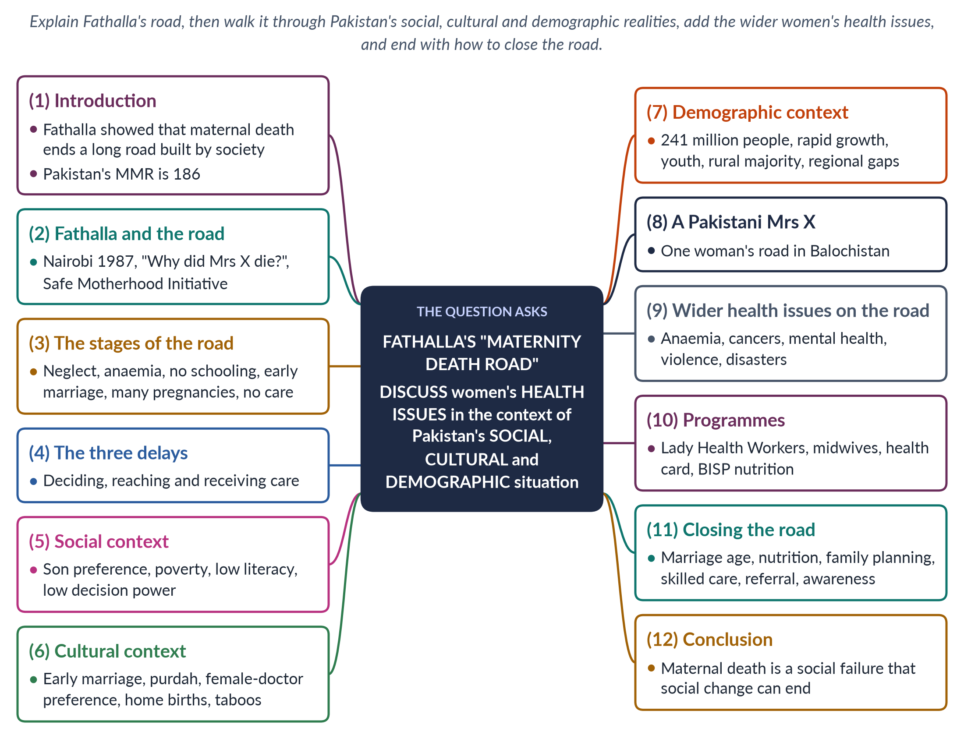
Figure 13 · The answer map: every branch is one numbered heading of the model answer below.

Decoding the question
The question quotes Mahmoud Fathalla's idea of the "maternity death road" (usually called the "road to maternal death"). "Discuss women's health issues in the context of Pakistan's social, cultural and demographic situation" asks you to apply his framework: show how each stage of the road is shaped by social (poverty, status), cultural (customs, norms) and demographic (population, age, rural–urban) factors in Pakistan. Use three headings for the three contexts.

The model answer

1. Introduction

i) The idea
The Egyptian obstetrician Mahmoud Fathalla described maternal death as the end of a long road that begins long before pregnancy — with being born female and poor, undernourished, uneducated and married young. Most maternal deaths, he argued, are preventable; they reflect a society's neglect of women.

ii) The Pakistani picture
Pakistan's maternal mortality ratio was 186 per 100,000 live births (PMMS 2019), far higher in rural areas and Balochistan.

iii) The argument
In Pakistan the road to maternal death is paved by social disadvantage, cultural practices and demographic pressures. Closing it requires social change as much as medical care.

2. Fathalla and the road
At the Safe Motherhood Conference in Nairobi (1987), which launched the global Safe Motherhood Initiative, Fathalla told the story of "Mrs X" and asked, "Why did Mrs X die?" He traced her death back through a chain of neglect. His often-quoted conclusion was that women are not dying of diseases we cannot treat, but because societies have yet to decide that their lives are worth saving. This shifted global thinking from purely medical solutions towards women's rights and empowerment.

3. The stages of the road
The road begins when a girl is born female and poor and fed less than her brothers; she grows undernourished and anaemic, receives little schooling, is married young, has many pregnancies close together without family planning, receives no antenatal care, and meets a complication — haemorrhage, eclampsia, obstructed labour or infection — without skilled help.
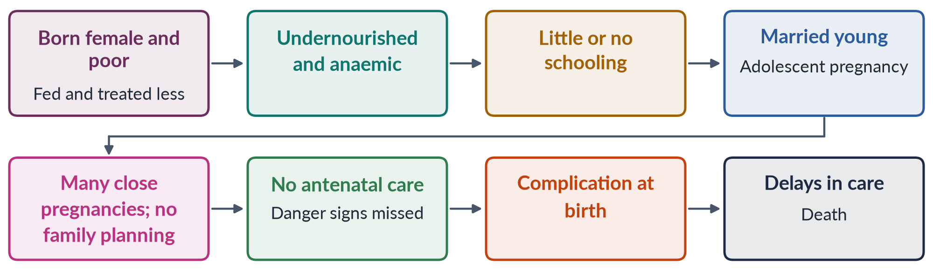
Figure 14 · The road to maternal death (after Fathalla, 1987).

4. The three delays
Sereen Thaddeus and Deborah Maine (1994) grouped the final stretch into three delays: (1) delay in deciding to seek care; (2) delay in reaching a facility; and (3) delay in receiving adequate care once there. Each delay has Pakistani causes, which the following sections trace through the social, cultural and demographic context.

5. The social context

i) Son preference and neglect of girls
Girls in many families receive less food and later medical care, so they reach adulthood undernourished — about 42% of women of reproductive age are anaemic (NNS 2018).

ii) Poverty
Poor families delay care because of the cost of transport, medicines and private treatment; most health spending in Pakistan is out of pocket.

iii) Low literacy
Female literacy is about 53% (Census 2023), far lower in rural areas; uneducated women know less about danger signs and family planning.

iv) Low decision-making power
Decisions about antenatal care and hospital delivery are often taken by husbands and mothers-in-law — the root of the first delay.

6. The cultural context

i) Early marriage
Many girls marry before 18. Only Sindh (2013) and Islamabad (2025) have set the minimum age at 18; the old federal age for girls is 16. Adolescent mothers face higher risks.

ii) Purdah and mobility
Many women need a male escort or permission to travel to a clinic — adding to the first and second delays.

iii) Preference for female health workers
Many women will not be examined by a male doctor, but female doctors are scarce in rural areas, and many women medical graduates do not practise.

iv) Home births and taboos
Home births with traditional attendants (dais) are common; taboos on discussing pregnancy and contraception limit information; pressure to bear sons leads to repeated pregnancies.

7. The demographic context

i) Rapid growth
The Census 2023 counted about 241 million people, growing at about 2.55% a year. The total fertility rate was about 3.6 and only 34% of married women used contraception (PDHS 2017–18).

ii) A young population
Large numbers of adolescent girls reach marriage age each year, so early marriage affects a very large number of young women.

iii) A rural majority and regional inequality
Most people live in rural areas where services are thinnest; Balochistan and parts of Sindh and Khyber Pakhtunkhwa have the worst indicators.

iv) Disasters
The 2022 floods left about 650,000 pregnant women in affected areas (UNFPA).
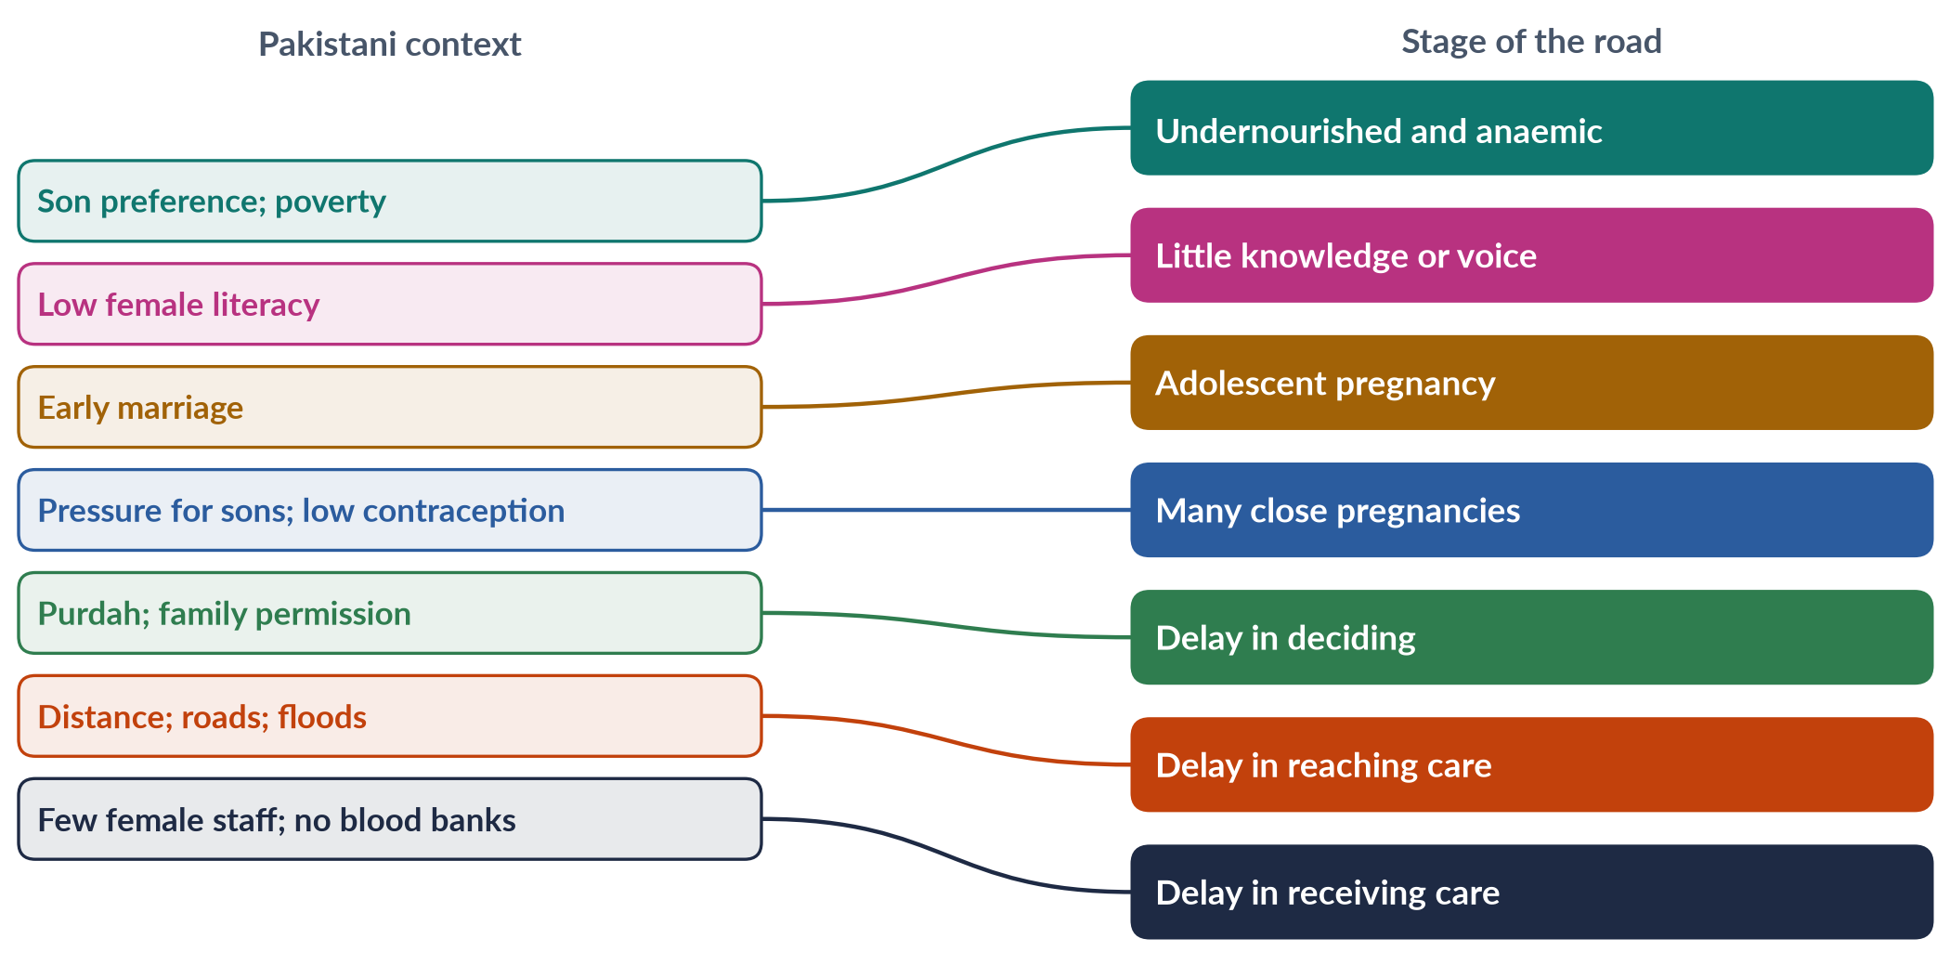
Figure 15 · Pakistan's context and the stage of the road it shapes.

8. A Pakistani Mrs X
Imagine a girl in rural Balochistan: fed after her brothers, out of school because the nearest girls' school was far away, married at fifteen, five pregnancies in eight years, anaemic throughout, never seen by a doctor. When she bleeds after her sixth home delivery, the family waits for her husband to decide; the nearest hospital with a blood bank is four hours away. She dies on the road. Every stage is a point where policy could have saved her.

Why Fathalla's framing matters for policy
Because each stage of the road is shaped by society, policy can intervene at each one: girls' education and nutrition early in life, an enforced minimum marriage age of 18, family planning, antenatal care, skilled birth attendance and emergency transport. A health system that waits only for the final emergency acts too late; Fathalla's road shows where to act sooner.

9. Wider health issues along the road
The road does not only lead to maternal death. Beyond it, the same social and cultural factors shape other women's health issues: anaemia and malnutrition; breast and cervical cancer diagnosed late because of shame and lack of screening; mental ill-health linked to violence and isolation; and domestic violence itself.

10. Programmes
The Lady Health Worker Programme (1994), community midwives, the Sehat Sahulat health card, BISP and nutrition programmes such as Benazir Nashonuma address parts of the road — but coverage and quality are uneven, and each tackles only one stage of a road that needs to be closed at every point.

11. Closing the road
Enforce an 18-year marriage age and keep girls in school; provide iron and nutrition support; widen family planning through LHWs and religious leaders; ensure antenatal care and skilled birth attendance; build emergency obstetric care with blood banks and ambulances; expand female staff and telemedicine; teach families the danger signs; and review every maternal death so that the system learns from each loss.

12. Conclusion
Fathalla's "road to maternal death" fits Pakistan closely. Its stages are shaped by social disadvantage (son preference, poverty, low literacy, low decision power), cultural practice (early marriage, purdah, home births, taboos) and demographic pressure (rapid growth, youth, rural majority, regional gaps). Because the road is built by society, society can close it — with education, nutrition, family planning, skilled care and women's empowerment.

Why this answer scores
- Explains Fathalla's idea accurately (Nairobi 1987, "Mrs X", the Safe Motherhood Initiative).
- Applies it through the question's own three lenses — social, cultural, demographic.
- A flow figure, a mapping figure and a Pakistani "Mrs X" make the analysis vivid.
- Ends with how to close the road at every stage.

Answer 7 · Pakistan in the Global Gender Gap Report 2025 (CSS 2026)
AT A GLANCE · CSS 2026 · Q4 · 20 MARKS
Evaluate Pakistan's performance in the World Economic Forum's Global Gender Gap Report 2025. Identify the socio-economic and political factors contributing to Pakistan's ranking, including labour-force participation, education, health and political empowerment.

The answer map
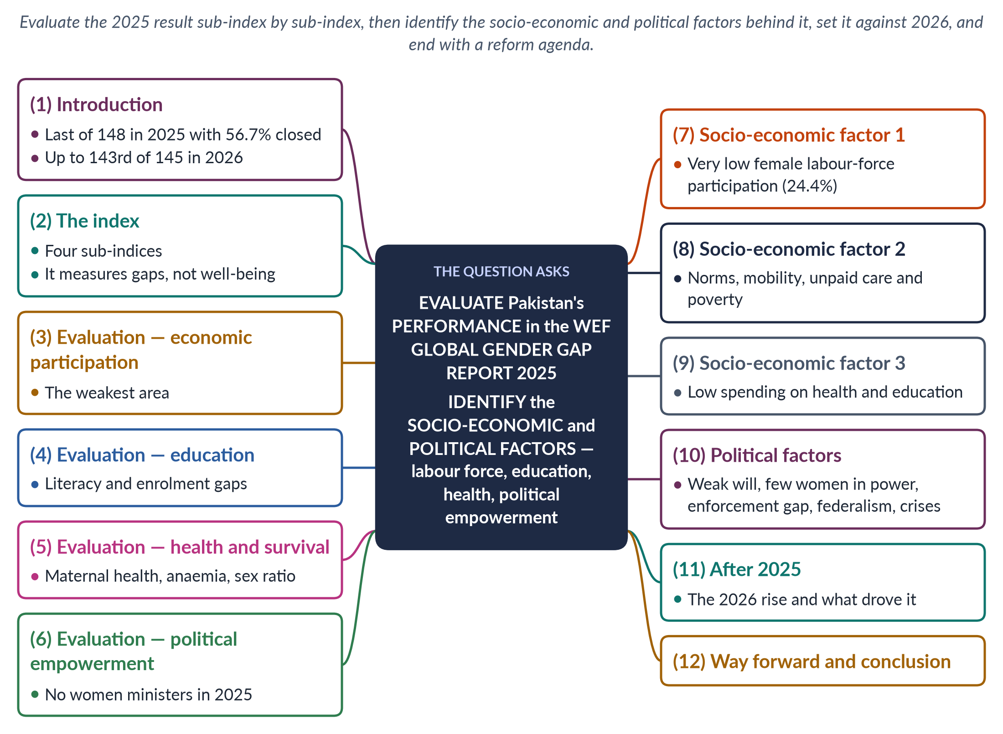
Figure 16 · The answer map: every branch is one numbered heading of the model answer below.

Decoding the question
"Evaluate Pakistan's performance" asks you to judge the 2025 result — not just state the rank but explain what it shows, sub-index by sub-index. "Identify the socio-economic and political factors" asks for causes, and the question lists four areas: labour-force participation, education, health and political empowerment — cover each. Mentioning the 2026 report shows currency.

The model answer

1. Introduction

i) The result
In the World Economic Forum's Global Gender Gap Report 2025, Pakistan ranked 148th of 148 economies — last — with 56.7% of its gender gap closed (about 57% in 2024).

ii) The context
The next year's report (2026) placed Pakistan 143rd of 145, with 59.5% closed — its strongest gain in a decade — though still the lowest in South Asia.

iii) The argument
Pakistan's 2025 performance was poor across the board and worst in economic participation. The causes are socio-economic — very low female employment, restrictive norms, unpaid care, poverty and low public spending — and political — weak will, few women in power and weak enforcement of laws.

2. The index
The Global Gender Gap Index, published since 2006, measures how much of the gap between women and men a country has closed in four sub-indices: economic participation and opportunity, educational attainment, health and survival, and political empowerment. It measures gaps, not levels of well-being, so a country's rank can fall even while it makes some progress, if others improve faster. A score of 100% would mean full parity; Pakistan's 56.7% means a little over half of the gap had been closed, against a global average of about 69%.

3. Evaluation — economic participation
This was Pakistan's weakest area. Female labour-force participation was only about a quarter of working-age women; women earn far less than men, and very few are managers, legislators or senior officials. In the 2026 report Pakistan still ranked 144th of 145 on this sub-index. The economic gap alone keeps Pakistan near the bottom.

4. Evaluation — educational attainment
Female literacy remains well below male literacy — about 53% against 68% in the Census 2023 (the WEF used a figure of about 48.5% for female literacy in 2025, up from 46.5%). More than 25 million children are out of school, most of them girls. The 2025 report recorded small gains, which became larger in 2026 (education rank 130th, up 11 places).

5. Evaluation — health and survival
Pakistan's maternal mortality ratio was 186 per 100,000 live births (2019); about 42% of women are anaemic; and son preference affects the sex ratio and girls' care. This sub-index is compressed for most countries, but Pakistan remains near the bottom.

6. Evaluation — political empowerment
The 2025 report found that the share of women among Pakistan's government ministers had fallen to zero (from 5.9% in 2024). Women's parliamentary presence depends mainly on 60 reserved seats; only 11 women won general National Assembly seats in the 2024 election. The appointment of Maryam Nawaz as the first woman chief minister of Punjab (2024) did not count in the index's national measures.
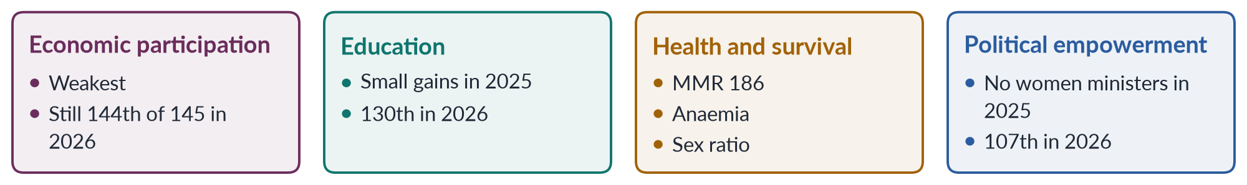
Figure 17 · Pakistan's performance by sub-index — the 2025 picture and the 2026 update.

7. Socio-economic factor 1: low female labour-force participation
Female participation was 24.4% in the Labour Force Survey 2024–25, among the lowest in the world, with wide provincial gaps (Punjab 33.8%, Balochistan 14.5%). Most working women are in agriculture and the informal sector, often unpaid, and their work is under-counted. The ILO has reported one of the world's widest gender pay gaps in Pakistan.

8. Socio-economic factor 2: norms, mobility, care and poverty

i) Norms
Purdah, family honour, the male-breadwinner ideal and early marriage limit girls' schooling and women's work. Many families still see a daughter's paid job as a sign that the men cannot provide, so even educated women often leave work after marriage.

ii) Mobility and safety
Unsafe transport and harassment keep women from jobs and colleges. Few women drive or own vehicles, public buses are crowded and male-dominated, and a long or unsafe journey is often reason enough for a family to refuse permission.

iii) Unpaid care
Without childcare, women carry most household and care work. Time-use surveys show Pakistani women spending several times as many hours as men on cooking, cleaning, fetching water and caring for children and the elderly — work that no index counts as economic output.

iv) Poverty
Poor families invest scarce resources in sons, whom they expect to support them in old age, while daughters are expected to marry and leave. Girls are withdrawn from school first when money runs short, and their health care is delayed.

9. Socio-economic factor 3: low public spending
Public spending of roughly 1% of GDP on health and around 2% on education leaves rural women without schools, clinics and female staff, holding back the education and health sub-indices. Where no girls' middle school exists within walking distance, girls' schooling simply ends after primary level.

10. Political factors

i) Weak political will and representation
Few women hold power; gender equality is rarely a priority; the fall to zero women ministers shows how easily women can be left out of cabinet.

ii) The enforcement gap
Pakistan has many pro-women laws — on harassment (2010), honour killing (2016) and rape (2021) — but enforcement is weak.

iii) Federalism
After the 18th Amendment (2010), women's development moved to the provinces, whose laws and capacity differ.

iv) Crises
The 2022 floods, economic crisis and IMF-linked austerity strained budgets and women's livelihoods.
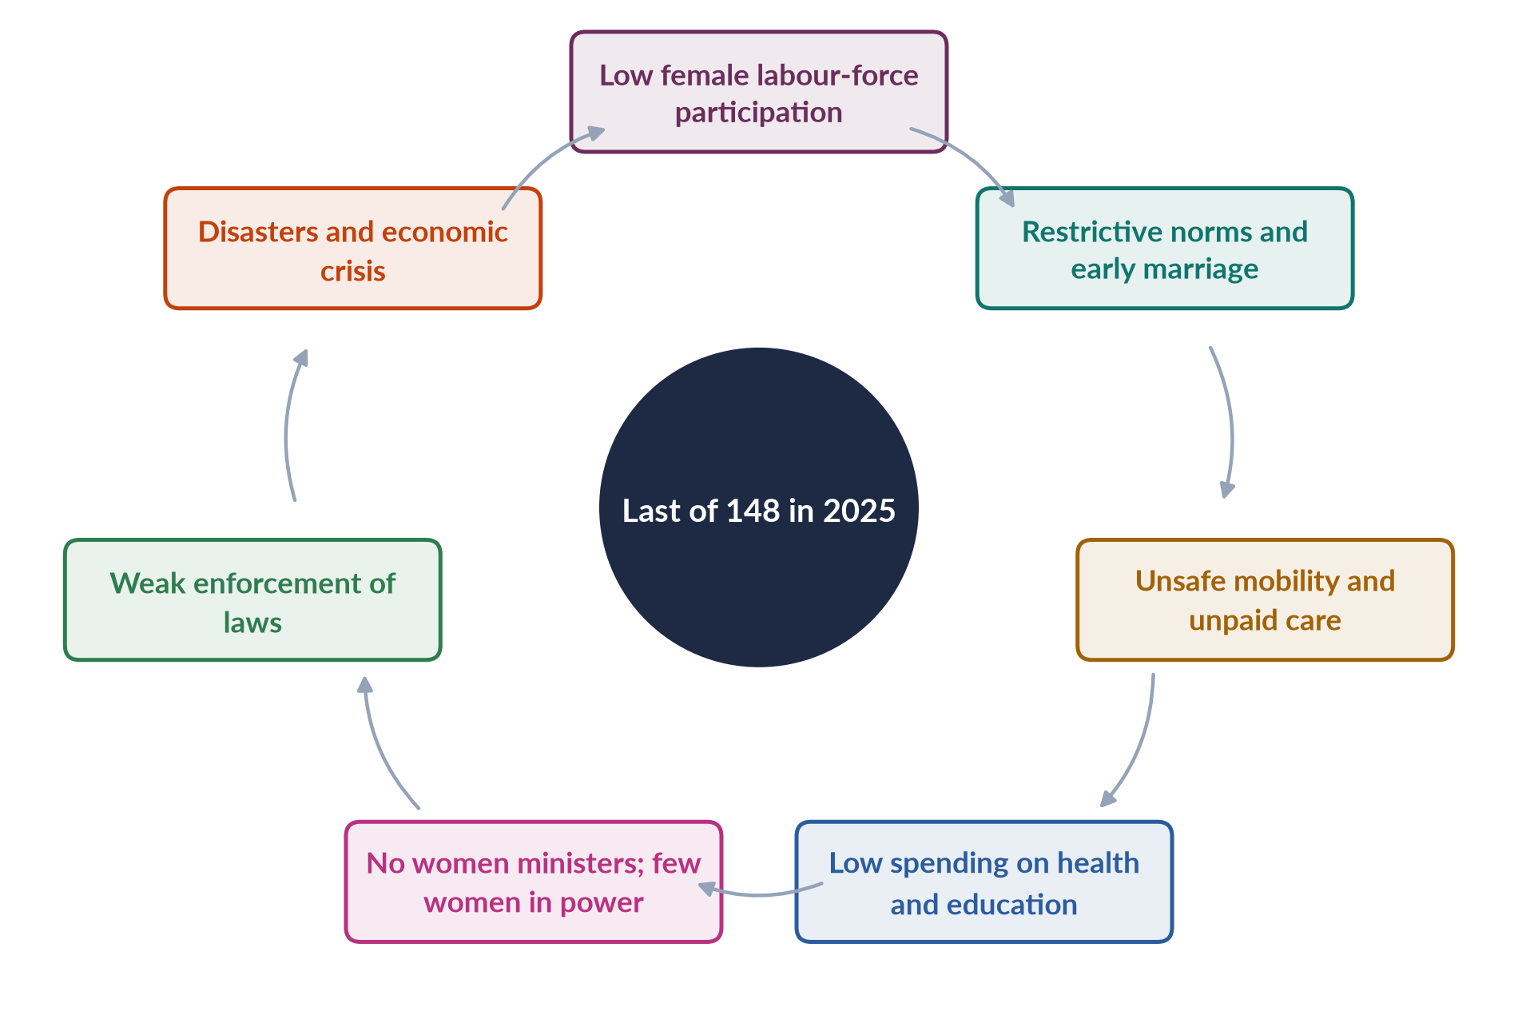
Figure 18 · The factors behind Pakistan's 2025 ranking.

In simple words
The index does not ask whether Pakistani women are rich or poor in absolute terms; it asks how far behind men they are. Pakistan finished last in 2025 mainly because its women are so far behind its men in paid work, with large gaps in literacy, health and political office adding to the deficit.

11. After 2025: the 2026 rise
In 2026 Pakistan rose to 143rd of 145 (59.5%), with education and political empowerment each up 11 places. The rise shows that the ranking can move quickly when girls' education improves and women are appointed to office. But the economic sub-index barely changed — the real test. A higher rank earned through appointments can be reversed by the next cabinet; a rise in women's employment is harder won but far more durable.

12. Way forward and conclusion

i) Way forward
Women's employment — safe transport, childcare, enforcement of the harassment law, protected home-based and digital work; girls' secondary education and an 18-year marriage age; primary health care and nutrition; women in cabinet and senior posts; enforcement of laws; and sex-disaggregated data.

ii) Conclusion
Pakistan's last-place finish in 2025 reflected long-standing gaps in economic participation, education, health and political voice, rooted in socio-economic barriers and weak political will. The 2026 improvement shows that policy matters. Sustained gains will depend above all on bringing more women into paid, decent work.

Why this answer scores
- Evaluates the 2025 result sub-index by sub-index, with data.
- Identifies socio-economic and political factors covering all four areas the question names.
- Uses the 2026 report to show currency and to test the analysis.
- A grid and a cycle figure summarise performance and causes.

Answer 8 · Intersectionality and Marginalised Women in Pakistan (CSS 2026)
AT A GLANCE · CSS 2026 · Q7 · 20 MARKS
Using intersectionality as an analytical framework, examine the experiences of marginalized groups of women in Pakistan, including rural women, ethnic and religious minorities, and differently-abled women. How do overlapping systems of oppression shape their access to health, education and employment?

The answer map
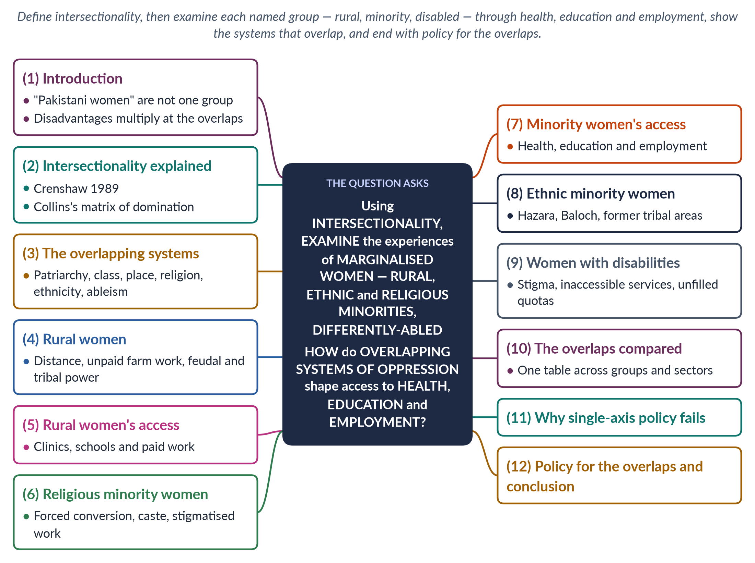
Figure 19 · The answer map: every branch is one numbered heading of the model answer below.

Decoding the question
"Using intersectionality as an analytical framework" means you must define it and then apply it — showing how gender combines with place, class, religion, ethnicity and disability. The question names three groups (rural women; ethnic and religious minorities; differently-abled women) and three sectors (health, education, employment). A strong answer covers every group and every sector — a table helps — and ends with policy.

The model answer

1. Introduction

i) The problem
National figures — female literacy of about 53%, labour-force participation of 24.4% — describe an "average" Pakistani woman who does not exist. A professional woman in Lahore and a landless Hindu labourer in Tharparkar are both "women", but their lives differ enormously.

ii) The argument
Intersectionality shows that gender combines with place, class, religion, ethnicity and disability to create multiplied disadvantage. Rural, minority and disabled women face overlapping systems of oppression that sharply limit their access to health, education and employment. Policy must be designed for these overlaps.

2. Intersectionality explained
The American legal scholar Kimberlé Crenshaw coined intersectionality in 1989, showing that Black women's discrimination could not be understood by looking at race or sex separately. Disadvantages multiply, not simply add up. Patricia Hill Collins (1990) called the way overlapping oppressions are organised — through laws, institutions, everyday practices and ideas — a matrix of domination.

3. The overlapping systems in Pakistan
The systems that overlap are patriarchy (norms of honour, purdah, early marriage), class (poverty and landlessness), place (rural remoteness and regional inequality), religion and caste (minority status), ethnicity (conflict and neglect in some regions) and ableism (exclusion of people with disabilities). No woman experiences these one at a time: a poor Hindu girl in rural Sindh meets poverty, remoteness, caste, religion and gender together, and each makes the others harder to escape.
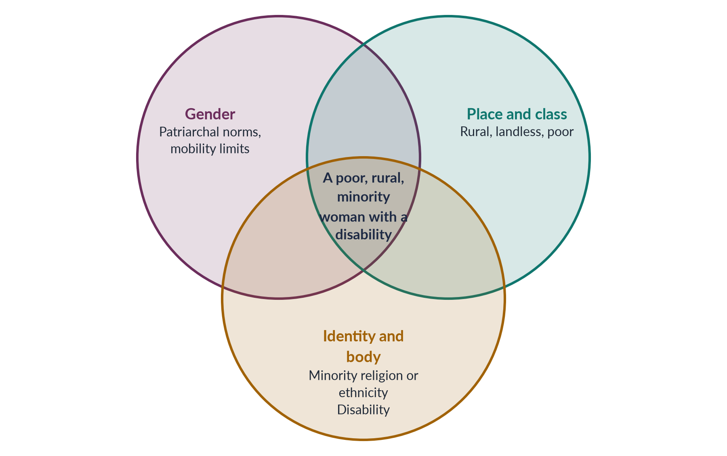
Figure 20 · Overlapping systems of oppression for marginalised women in Pakistan.

4. Rural women
Most Pakistani women live in rural areas. They face distance from services, heavy unpaid farm and livestock work, and feudal and tribal power structures — including jirgas and customs such as vani and swara — alongside gender norms.

5. Rural women's access

i) Health
Clinics are far away, female doctors scarce and home births common; maternal mortality is far higher than in cities.

ii) Education
Few villages have girls' middle and secondary schools; distance and safety fears keep girls home after primary school.

iii) Employment
Women work in fields for little or no pay; wages often go to husbands; women rarely own land or receive credit.

6. Religious minority women
Hindu, Christian, Sikh and Ahmadi women face gender plus religious disadvantage. Human-rights groups report cases each year of young Hindu and Christian girls, especially in Sindh and Punjab, abducted, converted and married. Many scheduled-caste Hindu women in Sindh are landless labourers, some in bonded labour; many Christian women work in stigmatised sanitation and domestic jobs. Until the Sindh Hindu Marriage Act 2016 and the federal Hindu Marriage Act 2017, Hindu marriages could not be registered.

7. Minority women's access

i) Health
Poor settlements and discrimination limit access to care. Many minority families live in informal colonies without clean water or sanitation, and some women report being treated with contempt or kept waiting at public facilities.

ii) Education
Poverty, discrimination in textbooks and schools, and the risk of abduction keep girls out of school. Parents who fear abduction and forced conversion may keep adolescent daughters at home altogether, so the threat of violence becomes an education barrier.

iii) Employment
Work is concentrated in low-status, unsafe jobs with no protection; the lack of marriage registration can block inheritance and identity documents. Christian sanitation workers — mostly from poor, formerly low-caste families — have died cleaning sewers without safety equipment, a stark example of caste, class and religion combining in the labour market.

8. Ethnic minority women
Hazara women in Quetta have lived through targeted attacks on their community; many are widows supporting families under restricted movement. Women in remote districts of Balochistan face the country's worst health and education indicators, and conflict adds insecurity. Women in the former tribal areas (merged with Khyber Pakhtunkhwa in 2018) faced militancy and the destruction of girls' schools.

9. Women with disabilities
Women with disabilities face stigma, exclusion from school, inaccessible transport, buildings and clinics, neglect of their reproductive health, poor marriage prospects and a higher risk of abuse. A job quota for persons with disabilities has existed since the Disabled Persons Ordinance 1981, and Pakistan ratified the UN Convention on the Rights of Persons with Disabilities in 2011, but quotas often go unfilled and data on disabled women are poor. The ICT Rights of Persons with Disability Act 2020 promised accessible buildings and inclusive education, yet a deaf or blind girl in a village still rarely finds a school that can teach her.

10. The overlaps compared
Table 2 · How overlapping oppression shapes access for marginalised women.
Group | Health | Education | Employment
Rural women | Distance; few female staff; home births | Few girls' secondary schools | Unpaid farm work; no land
Religious minorities | Poor settlements; discrimination | Poverty; bias; abduction risk | Sanitation, domestic, bonded work
Ethnic minorities | Worst indicators; conflict | School destruction; insecurity | Restricted movement; few jobs
Disabled women | Inaccessible clinics; reproductive neglect | Exclusion from schools | Unfilled quotas; stigma

An example: one village, three women
In a village in Tharparkar, a landlord's daughter may attend college in Hyderabad; a Muslim tenant's daughter may finish primary school; and a Hindu scheduled-caste girl with a disability may never enter a classroom. All three are "rural women", yet their access to education differs completely because of class, religion, caste and disability. Intersectionality makes these differences visible.

11. Why single-axis policy fails
A general women's programme may not reach minority women; a disability programme may not reach disabled women; a rural programme may not reach landless women. Because disadvantages multiply at the overlaps, the women who most need help are the ones most often missed. National averages hide them. A rise in the national female literacy rate can come entirely from urban, better-off women while the literacy of rural minority girls stays almost unchanged — which is why disaggregated data are the first step of intersectional policy.

12. Policy for the overlaps and conclusion

i) Policy
Mobile health teams and women health workers for remote areas; accessible girls' schools and transport; legal protection against forced conversion and child marriage, with courts that verify age and consent; social security for home-based, domestic and sanitation workers; CNIC and marriage-registration drives for poor and minority women; enforcement of disability quotas; disaggregated data by sex, religion, disability, region and income; and representation of marginalised women in commissions and planning.

ii) Conclusion
Intersectionality reveals that Pakistan's most marginalised women — rural, minority and disabled — face overlapping systems of patriarchy, poverty, remoteness, religious and ethnic exclusion and ableism. These systems compound one another to deny them health, education and decent work. Policy that serves "women" in general will keep missing them; policy designed for the overlaps can reach them.

Why this answer scores
- Defines intersectionality and applies it, as the question requires.
- Covers every named group and every named sector, with a summary table.
- A Venn figure shows the overlapping systems.
- Explains why single-axis policy fails and proposes policy for the overlaps.

Answer 9 · Short Note: Digital Transformation and the Narrowing Mobile Gender Gap (CSS 2026)
AT A GLANCE · CSS 2026 · Q8(A) · 10 MARKS
Write short notes on: Gendered implications of digital transformation and the narrowing mobile gender gap in Pakistan (2024-2025), including the fact that eight million more women came online and the mobile internet gender gap fell from 38% to 25%

The answer map
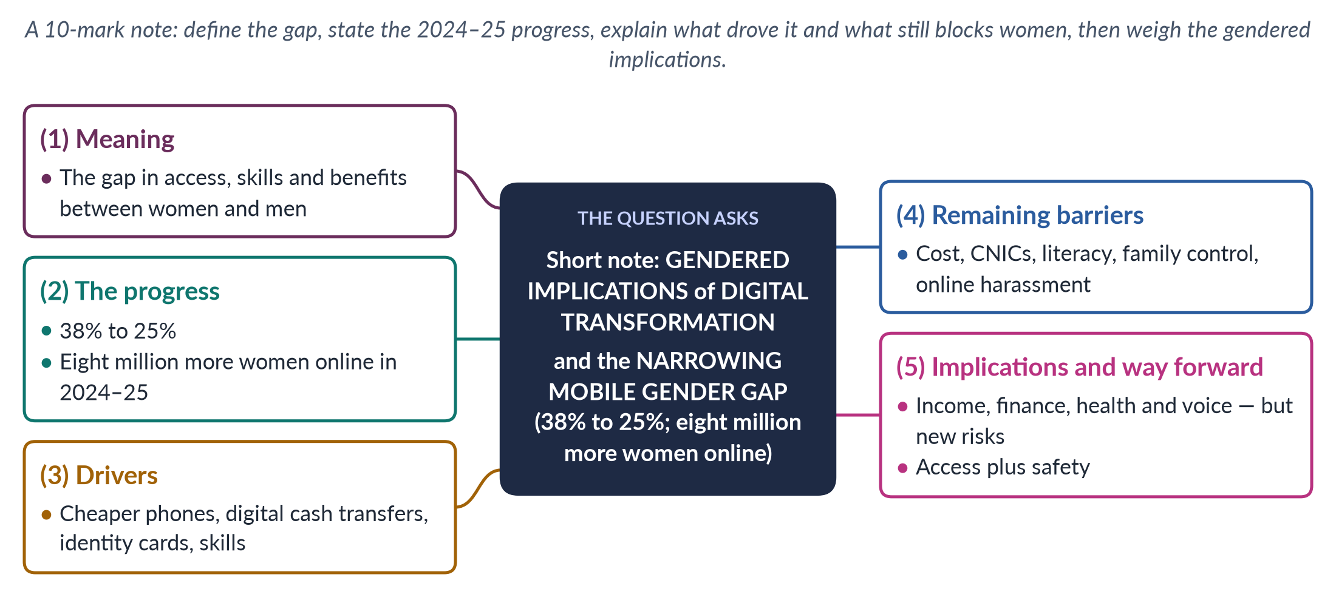
Figure 21 · The answer map for the short note: every branch is one headed point.

Decoding the question
A short note of 10 marks: about 550–650 words. The question supplies the key data (38% → 25%; eight million women). Define the gap, explain the drivers and remaining barriers, and discuss the gendered implications — opportunities and risks — ending with brief policy.

The model answer

1. Meaning
The digital gender gap is the difference between women and men in access to phones and the internet, in the skills to use them, and in the benefits they bring. The GSMA, the association of mobile operators, measures the mobile gap in its annual Mobile Gender Gap Report; South Asia has long had the world's widest gaps. A gap of 38% means that, for every 100 men using mobile internet, only about 62 women did.

2. The progress
Between 2024 and 2025, Pakistan's mobile-internet gender gap fell from 38% to 25%, and about eight million more women came online. This is significant progress — but a 25% gap still means women are a quarter less likely than men to use mobile internet, and the gap is widest among rural, poorer, older and less-educated women. Gaps in phone ownership and in smartphone ownership remain significant, and many women who are counted as users rely on a family member's handset.

3. What drove the change
1. Cheaper smartphones and data.
2. Digital cash transfers — BISP payments through biometric and mobile systems brought poor women into digital finance.
3. Identity cards — more women registered for CNICs, which are required to buy a SIM.
4. Skills and awareness programmes by government, operators and NGOs.
5. Social media and online work — messaging, video and freelancing platforms drew women online. Once a few women in a family or neighbourhood are online, others follow — a network effect that helps explain the speed of the change.

4. Remaining barriers
- Cost of phones and data for women with little income; handsets are usually bought by, and registered to, men.
- CNIC requirements for SIM registration — millions of women, especially rural and poor women, still lack an identity card.
- Low literacy — female literacy is about 53% (Census 2023), and little online content exists in regional languages.
- Social norms — family disapproval; phones shared with or controlled by male relatives.
- Online harassment — abuse, blackmail and image-based abuse drive women offline; most do not report.

Why the gap matters
Digital access is now a gateway to cash transfers, banking, health information, education and work. When women are offline, they are cut off not only from the internet but from services and opportunities that are moving online — so the digital gap risks widening every other gender gap.

5. Gendered implications and the way forward
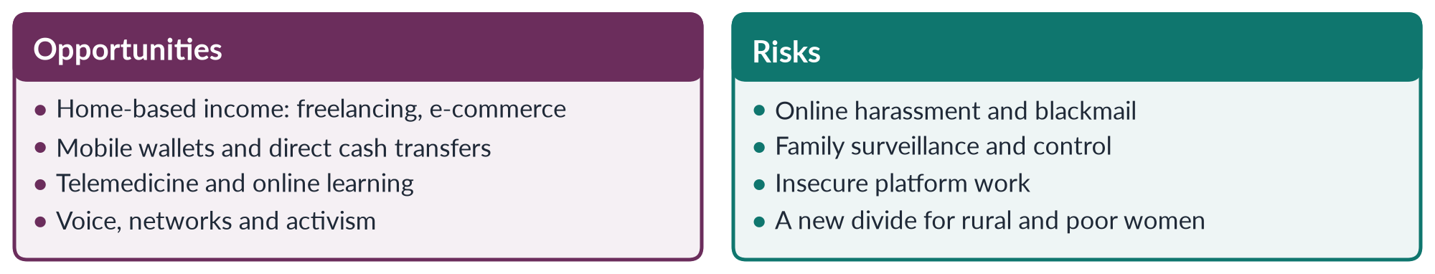
Figure 22 · Digital transformation: opportunities and risks for women.

i) Opportunities
For women whose mobility is restricted, digital tools open home-based income through freelancing and online selling, financial independence through mobile wallets, telemedicine with women doctors, online learning, and a voice in public debate.

ii) Risks
Online harassment and image-based abuse, surveillance by families, insecure platform work without protection, and a new divide if rural and poor women are left behind. The Prevention of Electronic Crimes Act 2016 criminalises online harassment, and the Digital Rights Foundation runs a helpline (from 2016), but reporting remains low: many women fear that complaining will bring shame on the family or end their own access to a phone.

iii) Way forward
Low-cost devices and data plans, with instalment schemes; CNIC drives for women; digital-skills training through schools, Lady Health Workers and BISP; faster, women-friendly cybercrime reporting; and services in local languages — in line with SDG target 5.b on using technology to empower women.

iv) Conclusion
The narrowing gap is a real gain: digital access can widen women's economic, health and civic opportunities. To make it empowering, access must be matched by skills and safety, and by women's own control over their phones, so that the next eight million women online are also secure, skilled and heard.

Why this answer scores
- Uses the question's data accurately and explains its source (GSMA).
- Covers drivers, barriers, opportunities and risks in a compact note.
- A compare figure shows the gendered implications at a glance.

